

Ain Shams University

Faculty Of Engineering

Computer And Information Systems Department

**Weather Data Analysis using Big-Data Analytics**

Supervised By

**Dr. Gamal A. Ebrahim**

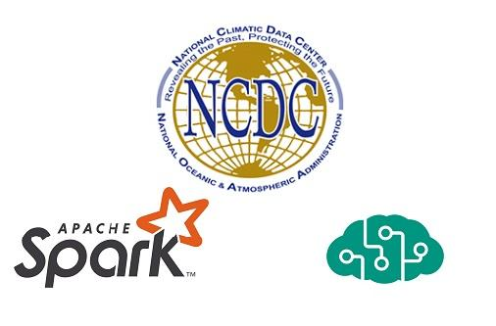

**Weather Data Analysis using Big-Data Analytics**

Supervised By

**Dr. Gamal A. Ebrahim**

# Group members:

* Mohammed Ali
* Maged Gamal
* Mostafa Saber
* Mohammed Shaden
* Mohammed Shrieff

# Table of contents:

1.1 Weather 15

1.2 Atmosphere of Earth 16

1.3 Principal layers 18

1.3.1 Exosphere 18

1.3.2 Thermosphere 19

1.3.3 Mesosphere 20

1.3.4 Stratosphere 20

1.3.5 Troposphere 21

1.4 Causes 23

1.5 Forecasting and Prediction 26

1.5.1 Ancient forecasting 27

1.5.2 Modern methods 28

1.5.3 Numerical prediction 29

1.5.4 Broadcasts 30

1.5.5 How models create forecasts 31

1.6 Effect on humans 34

1.7 Big Data 35

1.7.1 Definition 37

1.7.2 Characteristics 38

1.7.3 Architecture 39

1.7.4 Technologies 41

1.7.5 Applications 42

1.7.6 Case studies 46

1.7.7 Research activities 49

1.7.8 Critique 53

1.8 Big Data Lifecycle 57

1.8.1 Business Case Evaluation 57

1.8.2 Data Identification 58

1.8.3 Data Acquisition and Filtering 58

1.8.4 Data Extraction 58

1.8.5 Data Validation and Cleansing 59

1.8.6 Data Aggregation and Representation 59

1.8.7 Data Analysis 59

1.8.8 Data Visualization 60

1.8.9 Utilisation of Analysis Results 60

1.9 Apache Spark 61

1.10 NCDC 67

1.10.1 The NCDC Archive 69

1.10.2 NCEI 70

1.10.3 Methodology and Data Sources 71

**2.1 Discovery** 74

2.1.1 Domain knowledge 75

2.1.2 Problem and research 80

2.1.3 Past experiences 83

2.1.4 Resources 84

2.1.5 Analytics problem 89

2.1.6 Identifing Stakeholders and their interests 89

2.1.7 Pain points 89

2.1.8 Objectives, risks, and creteria. 90

2.1.9 Initial hypothesis 90

2.1.10 Learning the data 91

2.2 Data Preparation 94

2.2.1 Performing ETL (Extract Load Transform) 94

2.2.2 Data reduction and discretization 100

2.2.3 Data cleaning 101

2.2.4 Data integration 103

2.2.5 Data transformation 104

2.3 Model Planning and Selection 107

2.3.1 Classification: Logistic regression. 108

2.3.2 Classification: Naive Bayes. 108

2.3.3 Clustering: K-means. 108

2.3.4 Collaborative filtering. 109

2.3.5 Frequent Pattern Mining: FP-Growth 109

2.3.6 Technique and business value 110

2.4 Model Building 111

I. Create a hypothesis 111

II. Load and transform relevant data 111

III. Identify features 112

IV. Building the model 112

V. Evaluate the model 112

VI. Deploy the model 113

VII. Monitoring the model 113

2.4.1 Spliting the data 114

2.4.2 Fitting the model and user inputs 116

2.4.3 Creating the Frequent ItemSets 117

2.4.5 Creating the Association Rules 118

2.4.6 Transforming new data 119

2.5 Comunicate results 121

2.5.1 Creating web UI 121

2.5.2 Creating Mobile UI 123

3.1 Introduction 128

3.1.1 enterprise information management 128

3.1.2 Dialogue with consumers 129

3.1.3 Re-Develop Products 129

3.1.4 Perform risk analysis 130

3.1.5 Data safety 130

3.1.6 Create new revenue streams 130

3.1.7 Making the difference 131

3.2 Weather Services Becoming a Big Business 134

Glossery: 137

# Table of figures:

Figure 1.1: Cold night in Amsterdam 11

Figure 2: "Above the clouds with the moon" 12

Figure 3: Earth's atmospheric components 13

Figure 4: Earth's varying tempreture 20

Figure 5: wind rings used in forcasting 22

Figure 6: By Lee Jeffries. 24

Figure 7: Wind rings' intensity around the carribian 27

Figure 8: Hurrican Rita 28

Figure 9: Civilization by Lee Jeffries 30

Figure 10: Digital storage development 31

Figure 11: U.S. Cooperative Observer Network stations 63

Figure 12: NCDC Satellite archive 65

Figure 13: katrina-08-28-2005 66

Figure 14: 2017-billion-dollar-disaster-map 67

Figure 15: Data projects life cycle 69

Figure 16: Big Data framwork 70

Figure 17: Wind termonology 74

Figure 18: Time Periods termonology 74

Figure 19: Data Clustering 77

Figure 20: Scala vs Python 83

Figure 21: NCDC data of the Northern Africa region 88

Figure 22: Data attributes of the Northern Africa region 88

Figure 23: Un-usable data attributes 89

Figure 25: NCDC choosing a loctaion 91

Figure 24: NCDC tringlating the area of Los Angelos 91

Figure 26: NCDC adding multible locations 92

Figure 27: NCDC choosing output format 92

Figure 28: NCDC e=mail confirmation and completion 94

Figure 29: NCDC download link for ordered data 94

Figure 30: WT** transformation 96

Figure 31: WeatherType creation 96

Figure 32: Data missing values 98

Figure 33: Filling data missing values 98

Figure 34: Multible source data input 99

Figure 35: “Season” & “Month” columns 100

Figure 36: Numerical data before rounding 101

Figure 37: Numerical data after rounding 101

Figure 38: “T***~3” columns creation 102

Figure 39: Separating data values 102

Figure 40: FP-Growth Model 105

Figure 41: Predictive Analysis 106

Figure 42: Data splitting illustration 110

# Abstract:

The following document dicusses in details the steps taken to develop a Weather Data Analysis system. The system aims to predict the future weather behaviour by evidence of past collected data.

The system analyises data of huge span and size, this data is required to be extracted from the databases of the NCDC or any other database with the condition of similar structure.

Using Machine Learning algorithms the system analyses certain patterns and relations between the data points, producing rules that serves up to build the model. New data of recent proceedings can be applied on the ready-model producing pridiction values.

The scince of weather prediction attracts a fast growing interest from businesses, governments, and individuals in areas of weather difficulties, and this system might just revolutionize the weather prediction world.

# Acknowledgment:

We would like to offer our sincere gratitude to ***Prof. Dr. Gamal A. Ebrahim*** for providing us with guidence and advice along the way.

We’re also thankful for everyone who helped through our journy, and no-doubt they’re a huge part of making it memorable.

##### Chapter 1:

##### Introduction

# 1.1 Weather

Weather is the state of the atmosphere, describing for example the degree to which it is hot or cold, wet or dry, calm or stormy, clear or cloudy. Most weather phenomena occur in the lowest level of the atmosphere, the tropos-phere, just below the stratosphere. Weather refers to day-to-day temperature and precipitation activity, whereas climate is the term for the averaging of atmospheric conditions over longer periods of time. When used without qualification, "weather" is generally understood to mean the weather of Earth.

Weather is driven by air pressure, temperature and moisture differences between one place and another. These differences can occur due to the sun's angle at any particular spot, which varies with latitude. The strong temperature contrast between polar and tropical air gives rise to the largest scale

Figure 1.1: Cold night in Amsterdam

Figure 1: Cold night in Amsterdam

atmospheric circulations: the Hadley Cell, the Ferrel Cell, the Polar Cell, and the jet stream. Weather systems in the mid-latitudes, such as extratropical cyclones, are caused by instabilities of the jet stream flow. Because the Earth's axis is tilted relative to its orbital plane, sunlight is incident at different angles at different times of the year. On Earth's surface, temperatures usually range ±40 °C (−40 °F to 100 °F) annually. Over thousands of years, changes in Earth's orbit can affect the amount and distribution of solar energy received by the Earth, thus influencing long-term climate and global climate change.  
  
Surface temperature differences in turn cause pressure differences. Higher altitudes are cooler than lower altitudes, as most atmospheric heating is due to contact with the Earth's surface while radiative losses to space are mostly constant. Weather forecasting is the application of science and technology to predict the state of the atmosphere for a future time and a given location. The Earth's weather system is a chaotic system; as a result, small changes to one part of the system can grow to have large effects on the system as a whole. Human attempts to control the weather have occurred throughout history, and there is evidence that human activities such as agriculture and industry have modified weather patterns.  
  
Studying how the weather works on other planets has been helpful in understanding how weather works on Earth. A famous landmark in the Solar System, Jupiter's Great Red Spot, is an anticyclonic storm known to have existed for at least 300 years. However, weather is not limited to planetary bodies. A star's corona is constantly being lost to space, creating what is essentially a very thin atmosphere throughout the Solar System. The movement of mass ejected from the Sun is known as the solar wind.

# 1.2 Atmosphere of Earth

The atmosphere of Earth is the layer of gases, commonly known as air, that surrounds the planet Earth and is retained by Earth's gravity. The atmosphere of Earth protects life on Earth by creating pressure allowing for liquid water to exist on the Earth's surface, absorbing ultraviolet solar radiation, warming the surface through heat retention (greenhouse effect), and reducing temperature extremes between day and night (the diurnal temperature variation).



Figure 1.2: "Above the clouds with the moon"

by Lisa Kristine

Figure : "Above the clouds with the moon"

By volume, dry air contains 78.09% nitrogen, 20.95% oxygen, 0.93% argon, 0.04% carbon dioxide, and small amounts of other gases. Air also contains a variable amount of water vapor, on average around 1% at sea level, and 0.4% over the entire atmosphere. Air content and atmospheric pressure vary at different layers, and air suitable for use in photosynthesis by terrestrial plants and breathing of terrestrial animals is found only in Earth's troposphere and in artificial atmospheres.  
  
The atmosphere has a mass of about 5.15×1018 kg, three quarters of which is within about 11 km (6.8 mi; 36,000 ft) of the surface. The atmosphere becomes thinner and thinner with increasing altitude, with no definite boundary between the atmosphere and outer space. The Kármán line, at 100 km (62 mi), or 1.57% of Earth's radius, is often used as the border between the atmosphere and outer space. Atmospheric effects become noticeable during atmospheric reentry of spacecraft at an altitude of around 120 km (75 mi). Several layers can be distinguished in the atmosphere, based on characteristics such as temperature and composition.

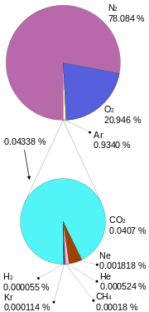  
The study of Earth's atmosphere and its processes is called atmospheric science (aerology). Early pioneers in the field include Léon Teisserenc de Bort and Richard Assmann.

Figure 1.3: Earth's atmospheric components

Figure : Earth's atmospheric components

The three major constituents of Earth's atmosphere, are nitrogen, oxygen, and argon. Water vapor accounts for roughly 0.25% of the atmosphere by mass. The concentration of water vapor (a greenhouse gas) varies significantly from around 10 ppm by volume in the coldest portions of the atmosphere to as much as 5% by volume in hot, humid air masses, and concentrations of other atmospheric gases are typically quoted in terms of dry air (without water vapor). The remaining gases are often referred to as trace gases, among which are the greenhouse gases, principally carbon dioxide, methane, nitrous oxide, and ozone. Filtered air includes trace amounts of many other chemical compounds. Many substances of natural origin may be present in locally and seasonally variable small amounts as aerosols in an unfiltered air sample, including dust of mineral and organic composition, pollen and spores, sea spray, and volcanic ash. Various industrial pollutants also may be present as gases or aerosols, such as chlorine (elemental or in compounds), fluorine compounds and elemental mercury vapor. Sulfur compounds such as hydrogen sulfide and sulfur dioxide (SO2) may be derived from natural sources or from industrial air pollution.

# 1.3 Principal layers

In general, air pressure and density decrease with altitude in the atmosphere. However, temperature has a more complicated profile with altitude, and may remain relatively constant or even increase with altitude in some regions (see the temperature section, below). Because the general pattern of the temperature/altitude profile is constant and measurable by means of instrumented balloon soundings, the temperature behavior provides a useful metric to distinguish atmospheric layers. In this way, Earth's atmosphere can be divided (called atmospheric stratification) into five main layers. Excluding the exosphere, the atmosphere has four primary layers, which are the troposphere, stratosphere, mesosphere, and thermosphere.From highest to lowest, the five main layers are:  
  
Exosphere: 700 to 10,000 km (440 to 6,200 miles)  
Thermosphere: 80 to 700 km (50 to 440 miles)  
Mesosphere: 50 to 80 km (31 to 50 miles)  
Stratosphere: 12 to 50 km (7 to 31 miles)  
Troposphere: 0 to 12 km (0 to 7 miles)

## 1.3.1 Exosphere

The exosphere is the outermost layer of Earth's atmosphere (i.e. the upper limit of the atmosphere). It extends from the exobase, which is located at the top of the thermosphere at an altitude of about 700 km above sea level, to about 10,000 km (6,200 mi; 33,000,000 ft) where it merges into the solar wind.  
  
This layer is mainly composed of extremely low densities of hydrogen, helium and several heavier molecules including nitrogen, oxygen and carbon dioxide closer to the exobase. The atoms and molecules are so far apart that they can travel hundreds of kilometers without colliding with one another. Thus, the exosphere no longer behaves like a gas, and the particles constantly escape into space. These free-moving particles follow ballistic trajectories and may migrate in and out of the magnetosphere or the solar wind.  
  
The exosphere is located too far above Earth for any meteorological phenomena to be possible. However, the aurora borealis and aurora australis sometimes occur in the lower part of the exosphere, where they overlap into the thermosphere. The exosphere contains most of the satellites orbiting Earth.

## 1.3.2 Thermosphere

The thermosphere is the second-highest layer of Earth's atmosphere. It extends from the mesopause (which separates it from the mesosphere) at an altitude of about 80 km (50 mi; 260,000 ft) up to the thermopause at an altitude range of 500–1000 km (310–620 mi; 1,600,000–3,300,000 ft). The height of the thermopause varies considerably due to changes in solar activity. Because the thermopause lies at the lower boundary of the exosphere, it is also referred to as the exobase. The lower part of the thermosphere, from 80 to 550 kilometres (50 to 342 mi) above Earth's surface, contains the ionosphere.  
  
The temperature of the thermosphere gradually increases with height. Unlike the stratosphere beneath it, wherein a temperature inversion is due to the absorption of radiation by ozone, the inversion in the thermosphere occurs due to the extremely low density of its molecules. The temperature of this layer can rise as high as 1500 °C (2700 °F), though the gas molecules are so far apart that its temperature in the usual sense is not very meaningful. The air is so rarefied that an individual molecule (of oxygen, for example) travels an average of 1 kilometre (0.62 mi; 3300 ft) between collisions with other molecules. Although the thermosphere has a high proportion of molecules with high energy, it would not feel hot to a human in direct contact, because its density is too low to conduct a significant amount of energy to or from the skin.  
  
This layer is completely cloudless and free of water vapor. However, non-hydrometeorological phenomena such as the aurora borealis and aurora australis are occasionally seen in the thermosphere. The International Space Station orbits in this layer, between 350 and 420 km (220 and 260 mi).

## 1.3.3 Mesosphere

The mesosphere is the third highest layer of Earth's atmosphere, occupying the region above the stratosphere and below the thermosphere. It extends from the stratopause at an altitude of about 50 km (31 mi; 160,000 ft) to the mesopause at 80–85 km (50–53 mi; 260,000–280,000 ft) above sea level.  
  
Temperatures drop with increasing altitude to the mesopause that marks the top of this middle layer of the atmosphere. It is the coldest place on Earth and has an average temperature around −85 °C (−120 °F; 190 K).  
  
Just below the mesopause, the air is so cold that even the very scarce water vapor at this altitude can be sublimated into polar-mesospheric noctilucent clouds. These are the highest clouds in the atmosphere and may be visible to the naked eye if sunlight reflects off them about an hour or two after sunset or a similar length of time before sunrise. They are most readily visible when the Sun is around 4 to 16 degrees below the horizon. Lightning-induced discharges known as transient luminous events (TLEs) occasionally form in the mesosphere above tropospheric thunderclouds. The mesosphere is also the layer where most meteors burn up upon atmospheric entrance. It is too high above Earth to be accessible to jet-powered aircraft and balloons, and too low to permit orbital spacecraft. The mesosphere is mainly accessed by sounding rockets and rocket-powered aircraft.

## 1.3.4 Stratosphere

The stratosphere is the second-lowest layer of Earth's atmosphere. It lies above the troposphere and is separated from it by the tropopause. This layer extends from the top of the troposphere at roughly 12 km (7.5 mi; 39,000 ft) above Earth's surface to the stratopause at an altitude of about 50 to 55 km (31 to 34 mi; 164,000 to 180,000 ft).  
  
The atmospheric pressure at the top of the stratosphere is roughly 1/1000 the pressure at sea level. It contains the ozone layer, which is the part of Earth's atmosphere that contains relatively high concentrations of that gas. The stratosphere defines a layer in which temperatures rise with increasing altitude. This rise in temperature is caused by the absorption of ultraviolet radiation (UV) radiation from the Sun by the ozone layer, which restricts turbulence and mixing. Although the temperature may be −60 °C (−76 °F; 210 K) at the tropopause, the top of the stratosphere is much warmer, and may be near 0 °C.  
  
The stratospheric temperature profile creates very stable atmospheric conditions, so the stratosphere lacks the weather-producing air turbulence that is so prevalent in the troposphere. Consequently, the stratosphere is almost completely free of clouds and other forms of weather. However, polar stratospheric or nacreous clouds are occasionally seen in the lower part of this layer of the atmosphere where the air is coldest. The stratosphere is the highest layer that can be accessed by jet-powered aircraft.

## 1.3.5 Troposphere

The troposphere is the lowest layer of Earth's atmosphere. It extends from Earth's surface to an average height of about 12 km, although this altitude varies from about 9 km (30,000 ft) at the poles to 17 km (56,000 ft) at the equator, with some variation due to weather. The troposphere is bounded above by the tropopause, a boundary marked in most places by a temperature inversion (i.e. a layer of relatively warm air above a colder one), and in others by a zone which is isothermal with height.  
  
Although variations do occur, the temperature usually declines with increasing altitude in the troposphere because the troposphere is mostly heated through energy transfer from the surface. Thus, the lowest part of the troposphere (i.e. Earth's surface) is typically the warmest section of the troposphere. This promotes vertical mixing (hence the origin of its name in the Greek word τρόπος, tropos, meaning "turn"). The troposphere contains roughly 80% of the mass of Earth's atmosphere. The troposphere is denser than all its overlying atmospheric layers because a larger atmospheric weight sits on top of the troposphere and causes it to be most severely compressed. Fifty percent of the total mass of the atmosphere is located in the lower 5.6 km (18,000 ft) of the troposphere.  
  
Nearly all atmospheric water vapor or moisture is found in the troposphere, so it is the layer where most of Earth's weather takes place. It has basically all the weather-associated cloud genus types generated by active wind circulation, although very tall cumulonimbus thunder clouds can penetrate the tropopause from below and rise into the lower part of the stratosphere. Most conventional aviation activity takes place in the troposphere, and it is the only layer that can be accessed by propeller-driven aircraft.  
  
  
Space Shuttle Endeavour orbiting in the thermosphere. Because of the angle of the photo, it appears to straddle the stratosphere and mesosphere that actually lie more than 250 km below. The orange layer is the troposphere, which gives way to the whitish stratosphere and then the blue mesosphere.  
Other layers  
Within the five principal layers that are largely determined by temperature, several secondary layers may be distinguished by other properties:  
  
The ozone layer is contained within the stratosphere. In this layer ozone concentrations are about 2 to 8 parts per million, which is much higher than in the lower atmosphere but still very small compared to the main components of the atmosphere. It is mainly located in the lower portion of the stratosphere from about 15–35 km (9.3–21.7 mi; 49,000–115,000 ft), though the thickness varies seasonally and geographically. About 90% of the ozone in Earth's atmosphere is contained in the stratosphere.

The ionosphere is a region of the atmosphere that is ionized by solar radiation. It is responsible for auroras. During daytime hours, it stretches from 50 to 1,000 km (31 to 621 mi; 160,000 to 3,280,000 ft) and includes the mesosphere, thermosphere, and parts of the exosphere. However, ionization in the mesosphere largely ceases during the night, so auroras are normally seen only in the thermosphere and lower exosphere. The ionosphere forms the inner edge of the magnetosphere. It has practical importance because it influences, for example, radio propagation on Earth.

The homosphere and heterosphere are defined by whether the atmospheric gases are well mixed. The surface-based homosphere includes the troposphere, stratosphere, mesosphere, and the lowest part of the thermosphere, where the chemical composition of the atmosphere does not depend on molecular weight because the gases are mixed by turbulence. This relatively homogeneous layer ends at the turbopause found at about 100 km (62 mi; 330,000 ft), the very edge of space itself as accepted by the FAI, which places it about 20 km (12 mi; 66,000 ft) above the mesopause.  
Above this altitude lies the heterosphere, which includes the exosphere and most of the thermosphere. Here, the chemical composition varies with altitude. This is because the distance that particles can move without colliding with one another is large compared with the size of motions that cause mixing. This allows the gases to stratify by molecular weight, with the heavier ones, such as oxygen and nitrogen, present only near the bottom of the heterosphere. The upper part of the heterosphere is composed almost completely of hydrogen, the lightest element.[clarification needed]

The planetary boundary layer is the part of the troposphere that is closest to Earth's surface and is directly affected by it, mainly through turbulent diffusion. During the day the planetary boundary layer usually is well-mixed, whereas at night it becomes stably stratified with weak or intermittent mixing. The depth of the planetary boundary layer ranges from as little as about 100 metres (330 ft) on clear, calm nights to 3,000 m (9,800 ft) or more during the afternoon in dry regions.

The average temperature of the atmosphere at Earth's surface is 14 °C (57 °F; 287 K) or 15 °C (59 °F; 288 K), depending on the reference.

# 1.4 Causes

On Earth, the common weather phenomena include wind, cloud, rain, snow, fog and dust storms. Less common events include natural disasters such as tornadoes, hurricanes, typhoons and ice storms. Almost all familiar weather phenomena occur in the troposphere (the lower part of the atmosphere). Weather does occur in the stratosphere and can affect weather lower down in the troposphere, but the exact mechanisms are poorly understood.  
  
Weather occurs primarily due to air pressure, temperature and moisture differences between one place to another. These differences can occur due to the sun angle at any particular spot, which varies by latitude from the tropics. In other words, the farther from the tropics one lies, the lower the sun angle is, which causes those locations to be cooler due the spread of the sunlight over a greater surface. The strong temperature contrast between polar and tropical air gives rise to the large scale atmospheric circulation cells and the jet stream. Weather systems in the mid-latitudes, such as extratropical cyclones, are caused by instabilities of the jet stream flow (see baroclinity). Weather systems in the tropics, such as monsoons or organized thunderstorm systems, are caused by different processes.  
  
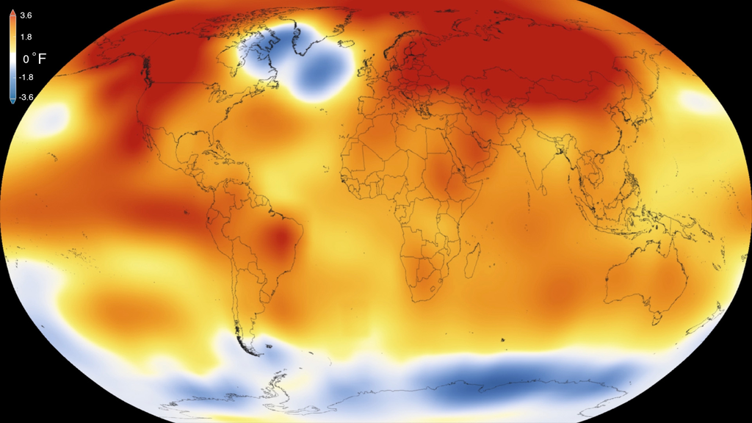

Figure : Earth's varying tempreture

Because the Earth's axis is tilted relative to its orbital plane, sunlight is incident at different angles at different times of the year. In June the Northern Hemisphere is tilted towards the sun, so at any given Northern Hemisphere latitude sunlight falls more directly on that spot than in December (see Effect of sun angle on climate). This effect causes seasons. Over thousands to hundreds of thousands of years, changes in Earth's orbital parameters affect the amount and distribution of solar energy received by the Earth and influence long-term climate. (See Milankovitch cycles).  
  
The uneven solar heating (the formation of zones of temperature and moisture gradients, or frontogenesis) can also be due to the weather itself in the form of cloudiness and precipitation. Higher altitudes are typically cooler than lower altitudes, which the result of higher surface temperature and radiational heating, which produces the adiabatic lapse rate.In some situations, the temperature actually increases with height. This phenomenon is known as an inversion and can cause mountaintops to be warmer than the valleys below. Inversions can lead to the formation of fog and often act as a cap that suppresses thunderstorm development. On local scales, temperature differences can occur because different surfaces (such as oceans, forests, ice sheets, or man-made objects) have differing physical characteristics such as reflectivity, roughness, or moisture content.  
  
Surface temperature differences in turn cause pressure differences. A hot surface warms the air above it causing it to expand and lower the density and the resulting surface air pressure. The resulting horizontal pressure gradient moves the air from higher to lower pressure regions, creating a wind, and the Earth's rotation then causes deflection of this air flow due to the Coriolis effect. The simple systems thus formed can then display emergent behaviour to produce more complex systems and thus other weather phenomena. Large scale examples include the Hadley cell while a smaller scale example would be coastal breezes.  
  
The atmosphere is a chaotic system. As a result, small changes to one part of the system can accumulate and magnify to cause large effects on the system as a whole. This atmospheric instability makes weather forecasting less predictable than tides or eclipses. Although it is difficult to accurately predict weather more than a few days in advance, weather forecasters are continually working to extend this limit through meteorological research and refining current methodologies in weather prediction. However, it is theoretically impossible to make useful day-to-day predictions more than about two weeks ahead, imposing an upper limit to potential for improved prediction skill.Weather is one of the fundamental processes that shape the Earth.  
  
 The process of weathering breaks down the rocks and soils into smaller fragments and then into their constituent substances. During rains precipitation, the water droplets absorb and dissolve carbon dioxide from the surrounding air. This causes the rainwater to be slightly acidic, which aids the erosive properties of water. The released sediment and chemicals are then free to take part in chemical reactions that can affect the surface further (such as acid rain), and sodium and chloride ions (salt) deposited in the seas/oceans. The sediment may reform in time and by geological forces into other rocks and soils. In this way, weather plays a major role in erosion of the surface.

# 1.5 Forecasting and Prediction

Weather forecasting is the application of science and technology to predict the conditions of the atmosphere for a given location and time. Human beings have attempted to predict the weather informally for millennia and formally since the 19th century. Weather forecasts are made by collecting quantitative data about the current state of the atmosphere at a given place and using meteorology to project how the atmosphere will change.

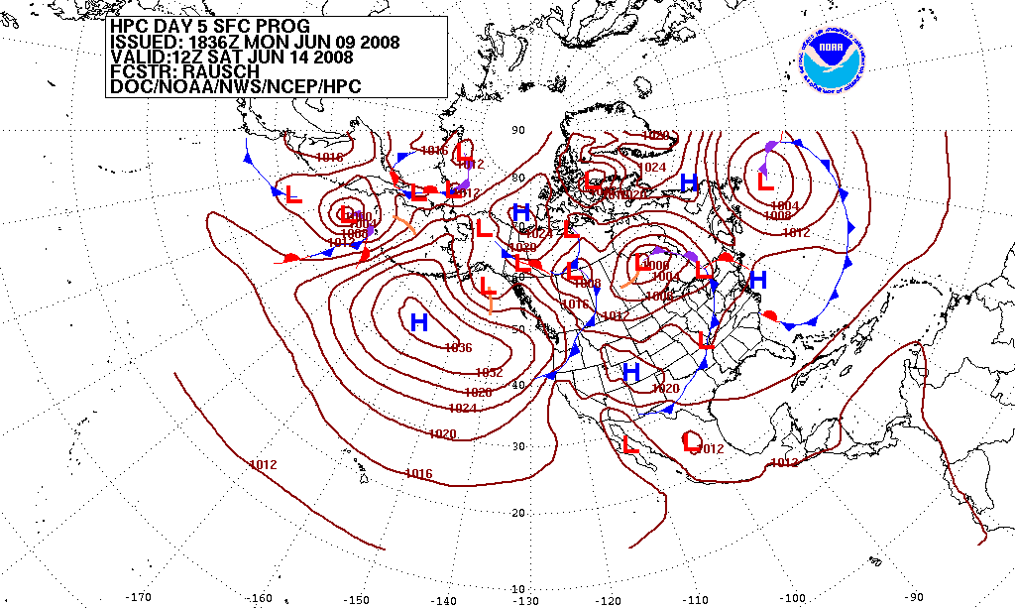  
Once a human-only endeavor based mainly upon changes in barometric pressure, current weather conditions, and sky condition or cloud cover, weather forecasting now relies on computer-based models that take many atmospheric factors into account. Human input is still required to pick the best possible forecast model to base the forecast upon, which involves pattern recognition skills, teleconnections, knowledge of model performance, and knowledge of model biases. The inaccuracy of forecasting is due to the chaotic nature of the atmosphere, the massive computational power required to solve the equations that describe the atmosphere, the error involved in measuring the initial conditions, and an incomplete understanding of atmospheric processes. Hence, forecasts become less accurate as the difference between current time and the time for which the forecast is being made (the range of the forecast) increases. The use of ensembles and model consensus help narrow the error and pick the most likely outcome.  
  
There are a variety of end uses to weather forecasts. Weather warnings are important forecasts because they are used to protect life and property. Forecasts based on temperature and precipitation are important to agriculture, and therefore to traders within commodity markets. Temperature forecasts are used by utility companies to estimate demand over coming days. On an everyday basis, people use weather forecasts to determine what to wear on a given day. Since outdoor activities are severely curtailed by heavy rain, snow and wind chill, forecasts can be used to plan activities around these events, and to plan ahead and survive them. In 2014, the US spent $5.1 billion on weather forecasting.

Figure 1.5: wind rings used in forcasting

Figure : wind rings used in forcasting

## 1.5.1 Ancient forecasting

For millennia people have tried to forecast the weather. In 650 BC, the Babylonians predicted the weather from cloud patterns as well as astrology. In about 350 BC, Aristotle described weather patterns in Meteorologica. Later, Theophrastus compiled a book on weather forecasting, called the Book of Signs. Chinese weather prediction lore extends at least as far back as 300 BC, which was also around the same time ancient Indian astronomers developed weather-prediction methods. In New Testament times, Christ himself referred to deciphering and understanding local weather patterns, by saying, "When evening comes, you say, 'It will be fair weather, for the sky is red', and in the morning, 'Today it will be stormy, for the sky is red and overcast.' You know how to interpret the appearance of the sky, but you cannot interpret the signs of the times."  
  
In 904 AD, Ibn Wahshiyya's Nabatean Agriculture discussed the weather forecasting of atmospheric changes and signs from the planetary astral alterations; signs of rain based on observation of the lunar phases; and weather forecasts based on the movement of winds.  
  
Ancient weather forecasting methods usually relied on observed patterns of events, also termed pattern recognition. For example, it might be observed that if the sunset was particularly red, the following day often brought fair weather. This experience accumulated over the generations to produce weather lore. However, not all[which?] of these predictions prove reliable, and many of them have since been found not to stand up to rigorous statistical testing.

## 1.5.2 Modern methods

It was not until the invention of the electric telegraph in 1835 that the modern age of weather forecasting began. Before that, the fastest that distant weather reports could travel was around 100 miles per day (160 km/d), but was more typically 40–75 miles per day (60–120 km/day) (whether by land or by sea). By the late 1840s, the telegraph allowed reports of weather conditions from a wide area to be received almost instantaneously,allowing forecasts to be made from knowledge of weather conditions further upwind.

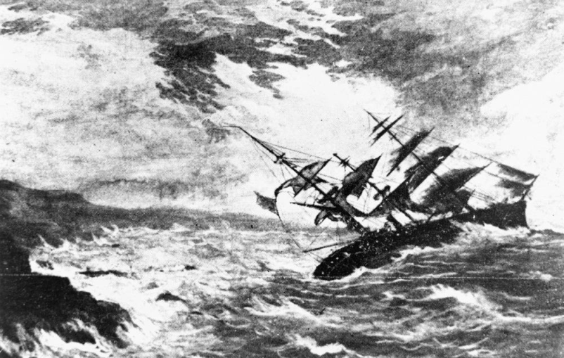The two men credited with the birth of forecasting as a science were officer of the Royal Navy Francis Beaufort and his protégé Robert FitzRoy. Both were influential men in British naval and governmental circles, and though ridiculed in the press at the time, their work gained scientific credence, was accepted by the Royal Navy, and formed the basis for all of today's weather forecasting knowledge.  
  
Beaufort developed the Wind Force Scale and Weather Notation coding, which he was to use in his journals for the remainder of his life. He also promoted the development of reliable tide tables around British shores, and with his friend William Whewell, expanded weather record-keeping at 200 British Coast guard stations.  
  
Robert FitzRoy was appointed in 1854 as chief of a new department within the Board of Trade to deal with the collection of weather data at sea as a service to mariners. This was the forerunner of the modern Meteorological Office. All ship captains were tasked with collating data on the weather and computing it, with the use of tested instruments that were loaned for this purpose.

Figure 1.6: By Lee Jeffries.

Figure : By Lee Jeffries.

A storm in 1859 that caused the loss of the Royal Charter inspired FitzRoy to develop charts to allow predictions to be made, which he called "forecasting the weather", thus coining the term "weather forecast". Fifteen land stations were established to use the telegraph to transmit to him daily reports of weather at set times leading to the first gale warning service. His warning service for shipping was initiated in February 1861, with the use of telegraph communications. The first daily weather forecasts were published in The Times in 1861. In the following year a system was introduced of hoisting storm warning cones at the principal ports when a gale was expected. The "Weather Book" which FitzRoy published in 1863 was far in advance of the scientific opinion of the time.  
  
As the electric telegraph network expanded, allowing for the more rapid dissemination of warnings, a national observational network was developed, which could then be used to provide synoptic analyses. Instruments to continuously record variations in meteorological parameters using photography were supplied to the observing stations from Kew Observatory – these cameras had been invented by Francis Ronalds in 1845 and his barograph had earlier been used by FitzRoy.  
  
To convey accurate information, it soon became necessary to have a standard vocabulary describing clouds; this was achieved by means of a series of classifications first achieved by Luke Howard in 1802, and standardized in the International Cloud Atlas of 1896.

## 1.5.3 Numerical prediction

It was not until the 20th century that advances in the understanding of atmospheric physics led to the foundation of modern numerical weather prediction. In 1922, English scientist Lewis Fry Richardson published "Weather Prediction By Numerical Process", after finding notes and derivations he worked on as an ambulance driver in World War I. He described therein how small terms in the prognostic fluid dynamics equations governing atmospheric flow could be neglected, and a finite differencing scheme in time and space could be devised, to allow numerical prediction solutions to be found.  
  
Richardson envisioned a large auditorium of thousands of people performing the calculations and passing them to others. However, the sheer number of calculations required was too large to be completed without the use of computers, and the size of the grid and time steps led to unrealistic results in deepening systems. It was later found, through numerical analysis, that this was due to numerical instability.The first computerised weather forecast was performed by a team composed of American meteorologists Jule Charney, Philip Thompson, Larry Gates, and Norwegian meteorologist Ragnar Fjørtoft, applied mathematician John von Neumann, and ENIAC programmer Klara Dan von Neumann. Practical use of numerical weather prediction began in 1955, spurred by the development of programmable electronic computers.

## 1.5.4 Broadcasts

The first ever daily weather forecasts were published in The Times on August 1, 1861, and the first weather maps were produced later in the same year. In 1911, the Met Office began issuing the first marine weather forecasts via radio transmission. These included gale and storm warnings for areas around Great Britain. In the United States, the first public radio forecasts were made in 1925 by Edward B. "E.B." Rideout, on WEEI, the Edison Electric Illuminating station in Boston. Rideout came from the U.S. Weather Bureau, as did WBZ weather forecaster G. Harold Noyes in 1931.  
  
The world's first televised weather forecasts, including the use of weather maps, were experimentally broadcast by the BBC in 1936. This was brought into practice in 1949 after World War II. George Cowling gave the first weather forecast while being televised in front of the map in 1954. In America, experimental television forecasts were made by James C Fidler in Cincinnati in either 1940 or 1947 on the DuMont Television Network. In the late 1970s and early 80s, John Coleman, the first weatherman on ABC-TV's Good Morning America, pioneered the use of on-screen weather satellite information and computer graphics for television forecasts. Coleman was a co-founder of The Weather Channel (TWC) in 1982. TWC is now a 24-hour cable network. Some weather channels have started broadcasting on live broadcasting programs such as YouTube and Periscope to reach more viewers.

1.5.5 How models create forecasts

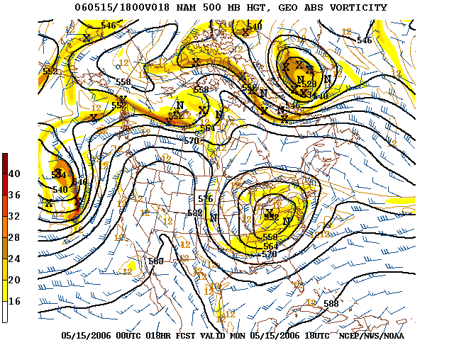The basic idea of numerical weather prediction is to sample the state of the fluid at a given time and use the equations of fluid dynamics and thermodynamics to estimate the state of the fluid at some time in the future. The main inputs from country-based weather services are surface observations from automated weather stations at ground level over land and from weather buoys at sea. The World Meteorological Organization acts to standardize the instrumentation, observing practices and timing of these observations worldwide. Stations either report hourly in METAR reports,or every six hours in SYNOP reports.Sites launch radiosondes, which rise through the depth of the troposphere and well into the stratosphere. Data from weather satellites are used in areas where traditional data sources are not available.Compared with similar data from radiosondes, the satellite data has the advantage of global coverage, however at a lower accuracy and resolution. Meteorological radar provide information on precipitation location and intensity, which can be used to estimate precipitation accumulations over time. Additionally, if a pulse Doppler weather radar is used then wind speed and direction can be determined.

Figure 1.7: Wind rings' intensity around the carribian

Figure : Wind rings' intensity around the carribian

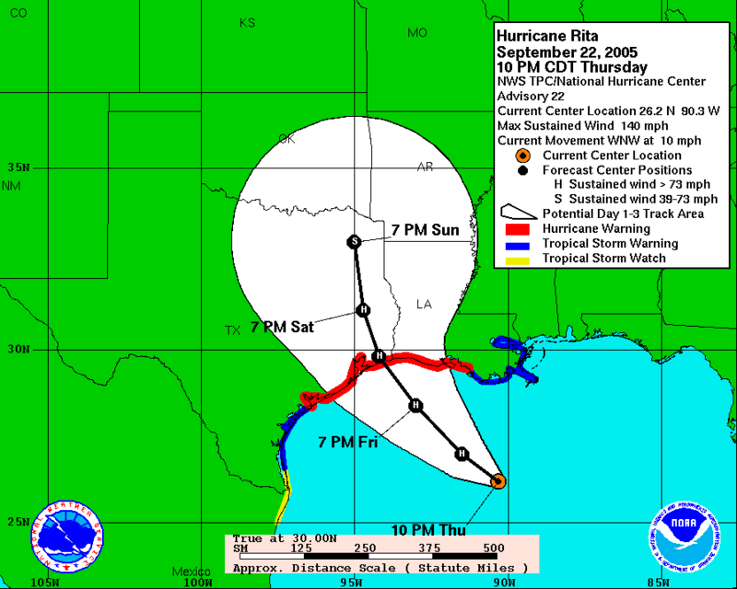

Figure 1.8 Hurrican Rita

Figure : Hurrican Rita

Commerce provides pilot reports along aircraft routes, and ship reports along shipping routes. Research flights using reconnaissance aircraft fly in and around weather systems of interest such as tropical cyclones. Reconnaissance aircraft are also flown over the open oceans during the cold season into systems that cause significant uncertainty in forecast guidance, or are expected to be of high impact 3–7 days into the future over the downstream continent.  
  
Models are initialized using this observed data. The irregularly spaced observations are processed by data assimilation and objective analysis methods, which perform quality control and obtain values at locations usable by the model's mathematical algorithms (usually an evenly spaced grid). The data are then used in the model as the starting point for a forecast. Commonly, the set of equations used to predict the known as the physics and dynamics of the atmosphere are called primitive equations. These equations are initialized from the analysis data and rates of change are determined. The rates of change predict the state of the atmosphere a short time into the future. The equations are then applied to this new atmospheric state to find new rates of change, and these new rates of change predict the atmosphere at a yet further time into the future. This time stepping procedure is continually repeated until the solution reaches the desired forecast time. The length of the time step is related to the distance between the points on the computational grid.  
  
The length of the time step chosen within the model is related to the distance between the points on the computational grid, and is chosen to maintain numerical stability.Time steps for global models are on the order of tens of minutes, while time steps for regional models are between one and four minutes. The global models are run at varying times into the future. The Met Office's Unified Model is run six days into the future, the European Centre for Medium-Range Weather Forecasts model is run out to 10 days into the future, while the Global Forecast System model run by the Environmental Modeling Center is run 16 days into the future. The visual output produced by a model solution is known as a prognostic chart, or prog. The raw output is often modified before being presented as the forecast. This can be in the form of statistical techniques to remove known biases in the model, or of adjustment to take into account consensus among other numerical weather forecasts. MOS or model output statistics is a technique used to interpret numerical model output and produce site-specific guidance. This guidance is presented in coded numerical form, and can be obtained for nearly all National Weather Service reporting stations in the United States. As proposed by Edward Lorenz in 1963, long range forecasts, those made at a range of two weeks or more, are impossible to definitively predict the state of the atmosphere, owing to the chaotic nature of the fluid dynamics equations involved. In numerical models, extremely small errors in initial values double roughly every five days for variables such as temperature and wind velocity.  
  
Essentially, a model is a computer program that produces meteorological information for future times at given locations and altitudes. Within any modern model is a set of equations, known as the primitive equations, used to predict the future state of the atmosphere. These equations—along with the ideal gas law—are used to evolve the density, pressure, and potential temperature scalar fields and the velocity vector field of the atmosphere through time. Additional transport equations for pollutants and other aerosols are included in some primitive-equation mesoscale models as well. The equations used are nonlinear partial differential equations, which are impossible to solve exactly through analytical methods, with the exception of a few idealized cases. Therefore, numerical methods obtain approximate solutions. Different models use different solution methods: some global models use spectral methods for the horizontal dimensions and finite difference methods for the vertical dimension, while regional models and other global models usually use finite-difference methods in all three dimensions.

# 1.6 Effect on humans

Weather, seen from an anthropological perspective, is something all humans in the world constantly experience through their senses, at least while being outside. There are socially and scientifically constructed understandings of what weather is, what makes it change, the effect it has on humans in different situations, etc. Therefore, weather is something people often communicate about.

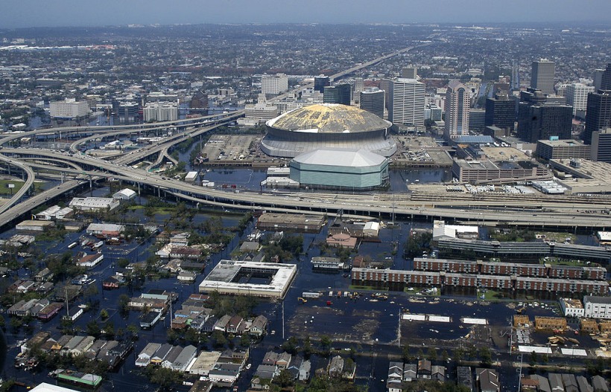Weather has played a large and sometimes direct part in human history. Aside from climatic changes that have caused the gradual drift of populations (for example the desertification of the Middle East, and the formation of land bridges during glacial periods), extreme weather events have caused smaller scale population movements and intruded directly in historical events. One such event is the saving of Japan from invasion by the Mongol fleet of Kublai Khan by the Kamikaze winds in 1281. French claims to Florida came to an end in 1565 when a hurricane destroyed the French fleet, allowing Spain to conquer Fort Caroline. More recently, Hurricane Katrina redistributed over one million people from the central Gulf coast elsewhere across the United States, becoming the largest diaspora in the history of the United States.  
  
The Little Ice Age caused crop failures and famines in Europe. The 1690s saw the worst famine in France since the Middle Ages. Finland suffered a severe famine in 1696–1697, during which about one-third of the Finnish population died.

Figure 1.9: Civilization by Lee Jeffries

Figure : Civilization by Lee Jeffries

# 1.7 Big Data

Big data is data sets that are so big and complex that traditional data-processing application software are inadequate to deal with them. Big data challenges include capturing data, data storage, data analysis, search, sharing, transfer, visualization, querying, updating, information privacy and data source. There are a number of concepts associated with big data: originally there were 3 concepts volume, variety, velocity. Other concepts later attributed with big data are veracity (i.e., how much noise is in the data) and value.

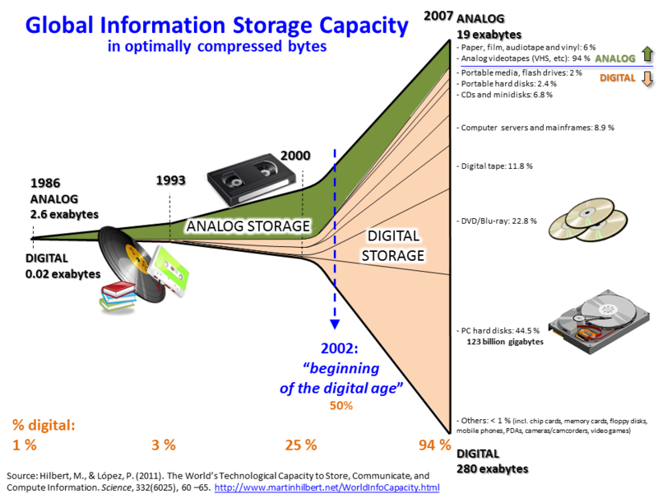  
Lately, the term "big data" tends to refer to the use of predictive analytics, user behavior analytics, or certain other advanced data analytics methods that extract value from data, and seldom to a particular size of data set. "There is little doubt that the quantities of data now available are indeed large, but that’s not the most relevant characteristic of this new data ecosystem." Analysis of data sets can find new correlations to "spot business trends, prevent diseases, combat crime and so on." Scientists, business executives, practitioners of medicine, advertising and governments alike regularly meet difficulties with large data-sets in areas including Internet search, fintech, urban informatics, and business informatics. Scientists encounter limitations in e-Science work, including meteorology, genomics, connectomics, complex physics simulations, biology and environmental research.  
  
Data sets grow rapidly - in part because they are increasingly gathered by cheap and numerous information-sensing Internet of things devices such as mobile devices, aerial (remote sensing), software logs, cameras, microphones, radio-frequency identification (RFID) readers and wireless sensor networks. The world's technological per-capita capacity to store information has roughly doubled every 40 months since the 1980s;as of 2012, every day 2.5 exabytes (2.5×1018) of data are generated.Based on an IDC report prediction, the global data volume will grow exponentially from 4.4 zettabytes to 44 zettabytes between 2013 and 2020. By 2025, IDC predicts there will be 163 zettabytes of data. One question for large enterprises is determining who should own big-data initiatives that affect the entire organization.  
  
Relational database management systems and desktop statistics[clarification needed] and software packages to visualize data often have difficulty handling big data. The work may require "massively parallel software running on tens, hundreds, or even thousands of servers". What counts as "big data" varies depending on the capabilities of the users and their tools, and expanding capabilities make big data a moving target. "For some organizations, facing hundreds of gigabytes of data for the first time may trigger a need to reconsider data management options. For others, it may take tens or hundreds of terabytes before data size becomes a significant consideration."

Figure 1.10: Digital storage development

Figure : Digital storage development

## 1.7.1 Definition

The term has been in use since the 1990s, with some giving credit to John Mashey for coining or at least making it popular. Big data usually includes data sets with sizes beyond the ability of commonly used software tools to capture, curate, manage, and process data within a tolerable elapsed time. Big data philosophy encompasses unstructured, semi-structured and structured data, however the main focus is on unstructured data. Big data "size" is a constantly moving target, as of 2012 ranging from a few dozen terabytes to many exabytes of data. Big data requires a set of techniques and technologies with new forms of integration to reveal insights from datasets that are diverse, complex, and of a massive scale.  
  
A 2016 definition states that "Big data represents the information assets characterized by such a high volume, velocity and variety to require specific technology and analytical methods for its transformation into value". Additionally, a new V, veracity, is added by some organizations to describe it, revisionism challenged by some industry authorities. The three Vs (volume, variety and velocity) have been further expanded to other complementary characteristics of big data:  
  
Machine learning: big data often doesn't ask why and simply detects patterns  
Digital footprint: big data is often a cost-free byproduct of digital interaction  
A 2018 definition states "Big data is where parallel computing tools are needed to handle data", and notes, "This represents a distinct and clearly defined change in the computer science used, via parallel programming theories, and losses of some of the guarantees and capabilities made by Codd’s relational model."   
  
The growing maturity of the concept more starkly delineates the difference between "big data" and "Business Intelligence":  
  
Business Intelligence uses descriptive statistics with data with high information density to measure things, detect trends, etc.  
Big data uses inductive statistics and concepts from nonlinear system identification to infer laws (regressions, nonlinear relationships, and causal effects) from large sets of data with low information density to reveal relationships and dependencies, or to perform predictions of outcomes and behaviors.

## 1.7.2 Characteristics

Big data can be described by the following characteristics:  
  
Volume  
The quantity of generated and stored data. The size of the data determines the value and potential insight, and whether it can be considered big data or not.

Variety  
The type and nature of the data. This helps people who analyze it to effectively use the resulting insight. Big data draws from text, images, audio, video; plus it completes missing pieces through data fusion.

Velocity  
In this context, the speed at which the data is generated and processed to meet the demands and challenges that lie in the path of growth and development. Big data is often available in real-time.

Veracity  
The data quality of captured data can vary greatly, affecting the accurate analysis.  
Factory work and Cyber-physical systems may have a 6C system:  
  
Connection (sensor and networks)  
Cloud (computing and data on demand)  
Cyber (model and memory)  
Content/context (meaning and correlation)  
Community (sharing and collaboration)  
Customization (personalization and value)  
Data must be processed with advanced tools (analytics and algorithms) to reveal meaningful information. For example, to manage a factory one must consider both visible and invisible issues with various components. Information generation algorithms must detect and address invisible issues such as machine degradation, component wear, etc. on the factory floor.

1.7.3 Architecture

Big data repositories have existed in many forms, often built by corporations with a special need. Commercial vendors historically offered parallel database management systems for big data beginning in the 1990s. For many years, WinterCorp published a largest database report.  
  
Teradata Corporation in 1984 marketed the parallel processing DBC 1012 system. Teradata systems were the first to store and analyze 1 terabyte of data in 1992. Hard disk drives were 2.5 GB in 1991 so the definition of big data continuously evolves according to Kryder's Law. Teradata installed the first petabyte class RDBMS based system in 2007. As of 2017, there are a few dozen petabyte class Teradata relational databases installed, the largest of which exceeds 50 PB. Systems up until 2008 were 100% structured relational data. Since then, Teradata has added unstructured data types including XML, JSON, and Avro.  
  
In 2000, Seisint Inc. (now LexisNexis Group) developed a C++-based distributed file-sharing framework for data storage and query. The system stores and distributes structured, semi-structured, and unstructured data across multiple servers. Users can build queries in a C++ dialect called ECL. ECL uses an "apply schema on read" method to infer the structure of stored data when it is queried, instead of when it is stored. In 2004, LexisNexis acquired Seisint Inc. and in 2008 acquired ChoicePoint, Inc. and their high-speed parallel processing platform. The two platforms were merged into HPCC (or High-Performance Computing Cluster) Systems and in 2011, HPCC was open-sourced under the Apache v2.0 License. Quantcast File System was available about the same time.  
  
CERN and other physics experiments have collected big data sets for many decades, usually analyzed via high performance computing (supercomputers) rather than the commodity map-reduce architectures usually meant by the current "big data" movement.  
  
In 2004, Google published a paper on a process called MapReduce that uses a similar architecture. The MapReduce concept provides a parallel processing model, and an associated implementation was released to process huge amounts of data. With MapReduce, queries are split and distributed across parallel nodes and processed in parallel (the Map step). The results are then gathered and delivered (the Reduce step). The framework was very successful, so others wanted to replicate the algorithm. Therefore, an implementation of the MapReduce framework was adopted by an Apache open-source project named Hadoop. Apache Spark was developed in 2012 in response to limitations in the MapReduce paradigm, as it adds the ability to set up many operations (not just map followed by reduce).  
  
MIKE2.0 is an open approach to information management that acknowledges the need for revisions due to big data implications identified in an article titled "Big Data Solution Offering". The methodology addresses handling big data in terms of useful permutations of data sources, complexity in interrelationships, and difficulty in deleting (or modifying) individual records.  
  
2012 studies showed that a multiple-layer architecture is one option to address the issues that big data presents. A distributed parallel architecture distributes data across multiple servers; these parallel execution environments can dramatically improve data processing speeds. This type of architecture inserts data into a parallel DBMS, which implements the use of MapReduce and Hadoop frameworks. This type of framework looks to make the processing power transparent to the end user by using a front-end application server.  
  
Big data analytics for manufacturing applications is marketed as a 5C architecture (connection, conversion, cyber, cognition, and configuration).  
  
The data lake allows an organization to shift its focus from centralized control to a shared model to respond to the changing dynamics of information management. This enables quick segregation of data into the data lake, thereby reducing the overhead time.

## 1.7.4 Technologies

A 2011 McKinsey Global Institute report characterizes the main components and ecosystem of big data as follows:

Techniques for analyzing data, such as A/B testing, machine learning and natural language processing

Big data technologies, like business intelligence, cloud computing and databases

Visualization, such as charts, graphs and other displays of the data

Multidimensional big data can also be represented as tensors, which can be more efficiently handled by tensor-based computation, such as multilinear subspace learning. Additional technologies being applied to big data include massively parallel-processing (MPP) databases, search-based applications, data mining, distributed file systems, distributed databases, cloud and HPC-based infrastructure (applications, storage and computing resources) and the Internet.[citation needed] Although, many approaches and technologies have been developed, it still remains difficult to carry out machine learning with big data.

Some MPP relational databases have the ability to store and manage petabytes of data. Implicit is the ability to load, monitor, back up, and optimize the use of the large data tables in the RDBMS.

DARPA's Topological Data Analysis program seeks the fundamental structure of massive data sets and in 2008 the technology went public with the launch of a company called Ayasdi.

The practitioners of big data analytics processes are generally hostile to slower shared storage, preferring direct-attached storage (DAS) in its various forms from solid state drive (SSD) to high capacity SATA disk buried inside parallel processing nodes. The perception of shared storage architectures—Storage area network (SAN) and Network-attached storage (NAS) —is that they are relatively slow, complex, and expensive. These qualities are not consistent with big data analytics systems that thrive on system performance, commodity infrastructure, and low cost.

Real or near-real time information delivery is one of the defining characteristics of big data analytics. Latency is therefore avoided whenever and wherever possible. Data in memory is good—data on spinning disk at the other end of a FC SAN connection is not. The cost of a SAN at the scale needed for analytics applications is very much higher than other storage techniques.

There are advantages as well as disadvantages to shared storage in big data analytics, but big data analytics practitioners as of 2011 did not favour it.

Big Data virtualization

Big Data virtualization is a way of gathering data from a few sources in a single layer. The gathered data layer is virtual. Unlike other methods, most of the data remains in place and is taken on demand directly from the source systems.

## 1.7.5 Applications

Big data has increased the demand of information management specialists so much so that Software AG, Oracle Corporation, IBM, Microsoft, SAP, EMC, HP and Dell have spent more than $15 billion on software firms specializing in data management and analytics. In 2010, this industry was worth more than $100 billion and was growing at almost 10 percent a year: about twice as fast as the software business as a whole.  
  
Developed economies increasingly use data-intensive technologies. There are 4.6 billion mobile-phone subscriptions worldwide, and between 1 billion and 2 billion people accessing the internet. Between 1990 and 2005, more than 1 billion people worldwide entered the middle class, which means more people became more literate, which in turn led to information growth. The world's effective capacity to exchange information through telecommunication networks was 281 petabytes in 1986, 471 petabytes in 1993, 2.2 exabytes in 2000, 65 exabytes in 2007 and predictions put the amount of internet traffic at 667 exabytes annually by 2014. According to one estimate, one-third of the globally stored information is in the form of alphanumeric text and still image data, which is the format most useful for most big data applications. This also shows the potential of yet unused data (i.e. in the form of video and audio content).  
  
While many vendors offer off-the-shelf solutions for big data, experts recommend the development of in-house solutions custom-tailored to solve the company's problem at hand if the company has sufficient technical capabilities.  
  
Government  
The use and adoption of big data within governmental processes allows efficiencies in terms of cost, productivity, and innovation, but does not come without its flaws. Data analysis often requires multiple parts of government (central and local) to work in collaboration and create new and innovative processes to deliver the desired outcome.  
  
CRVS (Civil Registration and Vital Statistics) collects all certificates status from birth to death. CRVS is a source of big data for governments.  
  
International development  
Research on the effective usage of information and communication technologies for development (also known as ICT4D) suggests that big data technology can make important contributions but also present unique challenges to International development. Advancements in big data analysis offer cost-effective opportunities to improve decision-making in critical development areas such as health care, employment, economic productivity, crime, security, and natural disaster and resource management. Additionally, user-generated data offers new opportunities to give the unheard a voice. However, longstanding challenges for developing regions such as inadequate technological infrastructure and economic and human resource scarcity exacerbate existing concerns with big data such as privacy, imperfect methodology, and interoperability issues.  
  
Manufacturing  
Based on TCS 2013 Global Trend Study, improvements in supply planning and product quality provide the greatest benefit of big data for manufacturing. Big data provides an infrastructure for transparency in manufacturing industry, which is the ability to unravel uncertainties such as inconsistent component performance and availability. Predictive manufacturing as an applicable approach toward near-zero downtime and transparency requires vast amount of data and advanced prediction tools for a systematic process of data into useful information. A conceptual framework of predictive manufacturing begins with data acquisition where different type of sensory data is available to acquire such as acoustics, vibration, pressure, current, voltage and controller data. Vast amount of sensory data in addition to historical data construct the big data in manufacturing. The generated big data acts as the input into predictive tools and preventive strategies such as Prognostics and Health Management (PHM).  
  
Healthcare  
Big data analytics has helped healthcare improve by providing personalized medicine and prescriptive analytics, clinical risk intervention and predictive analytics, waste and care variability reduction, automated external and internal reporting of patient data, standardized medical terms and patient registries and fragmented point solutions. Some areas of improvement are more aspirational than actually implemented. The level of data generated within healthcare systems is not trivial. With the added adoption of mHealth, eHealth and wearable technologies the volume of data will continue to increase. This includes electronic health record data, imaging data, patient generated data, sensor data, and other forms of difficult to process data. There is now an even greater need for such environments to pay greater attention to data and information quality. "Big data very often means `dirty data' and the fraction of data inaccuracies increases with data volume growth." Human inspection at the big data scale is impossible and there is a desperate need in health service for intelligent tools for accuracy and believability control and handling of information missed. While extensive information in healthcare is now electronic, it fits under the big data umbrella as most is unstructured and difficult to use.  
  
Education  
A McKinsey Global Institute study found a shortage of 1.5 million highly trained data professionals and managers and a number of universities including University of Tennessee and UC Berkeley, have created masters programs to meet this demand. Private bootcamps have also developed programs to meet that demand, including free programs like The Data Incubator or paid programs like General Assembly.In the specific field of marketing, one of the problems stressed by Wedel and Kannan is that marketing has several subdomains (e.g., advertising, promotions, product development, branding) that all use different types of data. Because one-size-fits-all analytical solutions are not desirable, business schools should prepare marketing managers to have wide knowledge on all the different techniques used in these subdomains to get a big picture and work effectively with analysts.

Media  
To understand how the media utilizes big data, it is first necessary to provide some context into the mechanism used for media process. It has been suggested by Nick Couldry and Joseph Turow that practitioners in Media and Advertising approach big data as many actionable points of information about millions of individuals. The industry appears to be moving away from the traditional approach of using specific media environments such as newspapers, magazines, or television shows and instead taps into consumers with technologies that reach targeted people at optimal times in optimal locations. The ultimate aim is to serve or convey, a message or content that is (statistically speaking) in line with the consumer's mindset. For example, publishing environments are increasingly tailoring messages (advertisements) and content (articles) to appeal to consumers that have been exclusively gleaned through various data-mining activities.  
  
Targeting of consumers (for advertising by marketers)   
Data capture  
Data journalism: publishers and journalists use big data tools to provide unique and innovative insights and infographics.  
Channel 4, the British public-service television broadcaster, is a leader in the field of big data and data analysis.  
  
Internet of Things (IoT)  
  
Big data and the IoT work in conjunction. Data extracted from IoT devices provides a mapping of device interconnectivity. Such mappings have been used by the media industry, companies and governments to more accurately target their audience and increase media efficiency. IoT is also increasingly adopted as a means of gathering sensory data, and this sensory data has been used in medical , manufacturing and transportation contexts.  
  
Kevin Ashton, digital innovation expert who is credited with coining the term, defines the Internet of Things in this quote: “If we had computers that knew everything there was to know about things—using data they gathered without any help from us—we would be able to track and count everything, and greatly reduce waste, loss and cost. We would know when things needed replacing, repairing or recalling, and whether they were fresh or past their best.”

Information Technology  
Especially since 2015, big data has come to prominence within Business Operations as a tool to help employees work more efficiently and streamline the collection and distribution of Information Technology (IT). The use of big data to resolve IT and data collection issues within an enterprise is called IT Operations Analytics (ITOA). By applying big data principles into the concepts of machine intelligence and deep computing, IT departments can predict potential issues and move to provide solutions before the problems even happen. In this time, ITOA businesses were also beginning to play a major role in systems management by offering platforms that brought individual data silos together and generated insights from the whole of the system rather than from isolated pockets of data.

## 1.7.6 Case studies

### Government

United States of America

In 2012, the Obama administration announced the Big Data Research and Development Initiative, to explore how big data could be used to address important problems faced by the government. The initiative is composed of 84 different big data programs spread across six departments.

Big data analysis played a large role in Barack Obama's successful 2012 re-election campaign.

The United States Federal Government owns four of the ten most powerful supercomputers in the world.

The Utah Data Center has been constructed by the United States National Security Agency. When finished, the facility will be able to handle a large amount of information collected by the NSA over the Internet. The exact amount of storage space is unknown, but more recent sources claim it will be on the order of a few exabytes. This has posed security concerns regarding the anonymity of the data collected.

India

Big data analysis was tried out for the BJP to win the Indian General Election 2014.

The Indian government utilizes numerous techniques to ascertain how the Indian electorate is responding to government action, as well as ideas for policy augmentation.

#### United Kingdom

Examples of uses of big data in public services:

Data on prescription drugs: by connecting origin, location and the time of each prescription, a research unit was able to exemplify the considerable delay between the release of any given drug, and a UK-wide adaptation of the National Institute for Health and Care Excellence guidelines. This suggests that new or most up-to-date drugs take some time to filter through to the general patient.

Joining up data: a local authority blended data about services, such as road gritting rotas, with services for people at risk, such as 'meals on wheels'. The connection of data allowed the local authority to avoid any weather-related delay.

#### Retail

Walmart handles more than 1 million customer transactions every hour, which are imported into databases estimated to contain more than 2.5 petabytes (2560 terabytes) of data—the equivalent of 167 times the information contained in all the books in the US Library of Congress.

Windermere Real Estate uses location information from nearly 100 million drivers to help new home buyers determine their typical drive times to and from work throughout various times of the day.

FICO Card Detection System protects accounts worldwide.

#### Science

The Large Hadron Collider experiments represent about 150 million sensors delivering data 40 million times per second. There are nearly 600 million collisions per second. After filtering and refraining from recording more than 99.99995% of these streams, there are 100 collisions of interest per second.

As a result, only working with less than 0.001% of the sensor stream data, the data flow from all four LHC experiments represents 25 petabytes annual rate before replication (as of 2012). This becomes nearly 200 petabytes after replication.

If all sensor data were recorded in LHC, the data flow would be extremely hard to work with. The data flow would exceed 150 million petabytes annual rate, or nearly 500 exabytes per day, before replication. To put the number in perspective, this is equivalent to 500 quintillion (5×1020) bytes per day, almost 200 times more than all the other sources combined in the world.

The Square Kilometre Array is a radio telescope built of thousands of antennas. It is expected to be operational by 2024. Collectively, these antennas are expected to gather 14 exabytes and store one petabyte per day. It is considered one of the most ambitious scientific projects ever undertaken.

When the Sloan Digital Sky Survey (SDSS) began to collect astronomical data in 2000, it amassed more in its first few weeks than all data collected in the history of astronomy previously. Continuing at a rate of about 200 GB per night, SDSS has amassed more than 140 terabytes of information. When the Large Synoptic Survey Telescope, successor to SDSS, comes online in 2020, its designers expect it to acquire that amount of data every five days.

Decoding the human genome originally took 10 years to process; now it can be achieved in less than a day. The DNA sequencers have divided the sequencing cost by 10,000 in the last ten years, which is 100 times cheaper than the reduction in cost predicted by Moore's Law.

The NASA Center for Climate Simulation (NCCS) stores 32 petabytes of climate observations and simulations on the Discover supercomputing cluster.

Google's DNAStack compiles and organizes DNA samples of genetic data from around the world to identify diseases and other medical defects. These fast and exact calculations eliminate any 'friction points,' or human errors that could be made by one of the numerous science and biology experts working with the DNA. DNAStack, a part of Google Genomics, allows scientists to use the vast sample of resources from Google's search server to scale social experiments that would usually take years, instantly.

23andme's DNA database contains genetic information of over 1,000,000 people worldwide. The company explores selling the "anonymous aggregated genetic data" to other researchers and pharmaceutical companies for research purposes if patients give their consent. Ahmad Hariri, professor of psychology and neuroscience at Duke University who has been using 23andMe in his research since 2009 states that the most important aspect of the company's new service is that it makes genetic research accessible and relatively cheap for scientists. A study that identified 15 genome sites linked to depression in 23andMe's database lead to a surge in demands to access the repository with 23andMe fielding nearly 20 requests to access the depression data in the two weeks after publication of the paper.

Computational Fluid Dynamics (CFD) and hydrodynamic turbulence research generate massive datasets. The Johns Hopkins Turbulence Databases (JHTDB) contains over 350 terabytes of spatiotemporal fields from Direct Numerical simulations of various turbulent flows. Such data have been difficult to share using traditional methods such as downloading flat simulation output files. The data within JHTDB can be accessed using "virtual sensors" with various access modes ranging from direct web-browser queries, access through Matlab, Python, Fortran and C programs executing on clients' platforms, to cut out services to download raw data. The data have been used in over 150 scientific publications.

#### Sports

Big data can be used to improve training and understanding competitors, using sport sensors. It is also possible to predict winners in a match using big data analytics. Future performance of players could be predicted as well. Thus, players' value and salary is determined by data collected throughout the season. The movie MoneyBall demonstrates how big data could be used to scout players and also identify undervalued players.

In Formula One races, race cars with hundreds of sensors generate terabytes of data. These sensors collect data points from tire pressure to fuel burn efficiency. Based on the data, engineers and data analysts decide whether adjustments should be made in order to win a race. Besides, using big data, race teams try to predict the time they will finish the race beforehand, based on simulations using data collected over the season.

#### Technology

eBay.com uses two data warehouses at 7.5 petabytes and 40PB as well as a 40PB Hadoop cluster for search, consumer recommendations, and merchandising.

Amazon.com handles millions of back-end operations every day, as well as queries from more than half a million third-party sellers. The core technology that keeps Amazon running is Linux-based and as of 2005 they had the world's three largest Linux databases, with capacities of 7.8 TB, 18.5 TB, and 24.7 TB.

Facebook handles 50 billion photos from its user base.

Google was handling roughly 100 billion searches per month as of August 2012.

## 

## 1.7.7 Research activities

Encrypted search and cluster formation in big data were demonstrated in March 2014 at the American Society of Engineering Education. Gautam Siwach engaged at Tackling the challenges of Big Data by MIT Computer Science and Artificial Intelligence Laboratory and Dr. Amir Esmailpour at UNH Research Group investigated the key features of big data as the formation of clusters and their interconnections. They focused on the security of big data and the orientation of the term towards the presence of different type of data in an encrypted form at cloud interface by providing the raw definitions and real time examples within the technology. Moreover, they proposed an approach for identifying the encoding technique to advance towards an expedited search over encrypted text leading to the security enhancements in big data.

In March 2012, The White House announced a national "Big Data Initiative" that consisted of six Federal departments and agencies committing more than $200 million to big data research projects.

The initiative included a National Science Foundation "Expeditions in Computing" grant of $10 million over 5 years to the AMPLab at the University of California, Berkeley. The AMPLab also received funds from DARPA, and over a dozen industrial sponsors and uses big data to attack a wide range of problems from predicting traffic congestion to fighting cancer.

The White House Big Data Initiative also included a commitment by the Department of Energy to provide $25 million in funding over 5 years to establish the Scalable Data Management, Analysis and Visualization (SDAV) Institute, led by the Energy Department’s Lawrence Berkeley National Laboratory. The SDAV Institute aims to bring together the expertise of six national laboratories and seven universities to develop new tools to help scientists manage and visualize data on the Department's supercomputers.

The U.S. state of Massachusetts announced the Massachusetts Big Data Initiative in May 2012, which provides funding from the state government and private companies to a variety of research institutions. The Massachusetts Institute of Technology hosts the Intel Science and Technology Center for Big Data in the MIT Computer Science and Artificial Intelligence Laboratory, combining government, corporate, and institutional funding and research efforts.

The European Commission is funding the 2-year-long Big Data Public Private Forum through their Seventh Framework Program to engage companies, academics and other stakeholders in discussing big data issues. The project aims to define a strategy in terms of research and innovation to guide supporting actions from the European Commission in the successful implementation of the big data economy. Outcomes of this project will be used as input for Horizon 2020, their next framework program.

The British government announced in March 2014 the founding of the Alan Turing Institute, named after the computer pioneer and code-breaker, which will focus on new ways to collect and analyse large data sets.

At the University of Waterloo Stratford Campus Canadian Open Data Experience (CODE) Inspiration Day, participants demonstrated how using data visualization can increase the understanding and appeal of big data sets and communicate their story to the world.

To make manufacturing more competitive in the United States (and globe), there is a need to integrate more American ingenuity and innovation into manufacturing ; Therefore, National Science Foundation has granted the Industry University cooperative research center for Intelligent Maintenance Systems (IMS) at university of Cincinnati to focus on developing advanced predictive tools and techniques to be applicable in a big data environment. In May 2013, IMS Center held an industry advisory board meeting focusing on big data where presenters from various industrial companies discussed their concerns, issues and future goals in big data environment.

Computational social sciences – Anyone can use Application Programming Interfaces (APIs) provided by big data holders, such as Google and Twitter, to do research in the social and behavioral sciences. Often these APIs are provided for free. Tobias Preis et al. used Google Trends data to demonstrate that Internet users from countries with a higher per capita gross domestic product (GDP) are more likely to search for information about the future than information about the past. The findings suggest there may be a link between online behaviour and real-world economic indicators. The authors of the study examined Google queries logs made by ratio of the volume of searches for the coming year ('2011') to the volume of searches for the previous year ('2009'), which they call the 'future orientation index'. They compared the future orientation index to the per capita GDP of each country, and found a strong tendency for countries where Google users inquire more about the future to have a higher GDP. The results hint that there may potentially be a relationship between the economic success of a country and the information-seeking behavior of its citizens captured in big data.

Tobias Preis and his colleagues Helen Susannah Moat and H. Eugene Stanley introduced a method to identify online precursors for stock market moves, using trading strategies based on search volume data provided by Google Trends. Their analysis of Google search volume for 98 terms of varying financial relevance, published in Scientific Reports, suggests that increases in search volume for financially relevant search terms tend to precede large losses in financial markets.

Big data sets come with algorithmic challenges that previously did not exist. Hence, there is a need to fundamentally change the processing ways.

The Workshops on Algorithms for Modern Massive Data Sets (MMDS) bring together computer scientists, statisticians, mathematicians, and data analysis practitioners to discuss algorithmic challenges of big data.

#### Sampling big data

An important research question that can be asked about big data sets is whether you need to look at the full data to draw certain conclusions about the properties of the data or is a sample good enough. The name big data itself contains a term related to size and this is an important characteristic of big data. But Sampling (statistics) enables the selection of right data points from within the larger data set to estimate the characteristics of the whole population. For example, there are about 600 million tweets produced every day. Is it necessary to look at all of them to determine the topics that are discussed during the day? Is it necessary to look at all the tweets to determine the sentiment on each of the topics? In manufacturing different types of sensory data such as acoustics, vibration, pressure, current, voltage and controller data are available at short time intervals.

To predict downtime it may not be necessary to look at all the data but a sample may be sufficient. Big Data can be broken down by various data point categories such as demographic, psychographic, behavioral, and transactional data. With large sets of data points, marketers are able to create and utilize more customized segments of consumers for more strategic targeting.

There has been some work done in Sampling algorithms for big data. A theoretical formulation for sampling Twitter data has been developed.

1.7.8 Critique

Critiques of the big data paradigm come in two flavors, those that question the implications of the approach itself, and those that question the way it is currently done. One approach to this criticism is the field of Critical data studies.

Critiques of the big data paradigm

"A crucial problem is that we do not know much about the underlying empirical micro-processes that lead to the emergence of the[se] typical network characteristics of Big Data". In their critique, Snijders, Matzat, and Reips point out that often very strong assumptions are made about mathematical properties that may not at all reflect what is really going on at the level of micro-processes. Mark Graham has leveled broad critiques at Chris Anderson's assertion that big data will spell the end of theory: focusing in particular on the notion that big data must always be contextualized in their social, economic, and political contexts.

Even as companies invest eight- and nine-figure sums to derive insight from information streaming in from suppliers and customers, less than 40% of employees have sufficiently mature processes and skills to do so. To overcome this insight deficit, big data, no matter how comprehensive or well analysed, must be complemented by "big judgment," according to an article in the Harvard Business Review.

Much in the same line, it has been pointed out that the decisions based on the analysis of big data are inevitably "informed by the world as it was in the past, or, at best, as it currently is". Fed by a large number of data on past experiences, algorithms can predict future development if the future is similar to the past. If the systems dynamics of the future change (if it is not a stationary process), the past can say little about the future. In order to make predictions in changing environments, it would be necessary to have a thorough understanding of the systems dynamic, which requires theory. As a response to this critique Alemany Oliver and Vayre suggested to use "abductive reasoning as a first step in the research process in order to bring context to consumers’ digital traces and make new theories emerge". Additionally, it has been suggested to combine big data approaches with computer simulations, such as agent-based models and Complex Systems. Agent-based models are increasingly getting better in predicting the outcome of social complexities of even unknown future scenarios through computer simulations that are based on a collection of mutually interdependent algorithms. Finally, use of multivariate methods that probe for the latent structure of the data, such as factor analysis and cluster analysis, have proven useful as analytic approaches that go well beyond the bi-variate approaches (cross-tabs) typically employed with smaller data sets.

In health and biology, conventional scientific approaches are based on experimentation. For these approaches, the limiting factor is the relevant data that can confirm or refute the initial hypothesis. A new postulate is accepted now in biosciences: the information provided by the data in huge volumes (omics) without prior hypothesis is complementary and sometimes necessary to conventional approaches based on experimentation. In the massive approaches it is the formulation of a relevant hypothesis to explain the data that is the limiting factor. The search logic is reversed and the limits of induction ("Glory of Science and Philosophy scandal", C. D. Broad, 1926) are to be considered.[citation needed]

Privacy advocates are concerned about the threat to privacy represented by increasing storage and integration of personally identifiable information; expert panels have released various policy recommendations to conform practice to expectations of privacy. The misuse of Big Data in several cases by media, companies and even the government has allowed for abolition of trust in almost every fundamental institution holding up society.

Nayef Al-Rodhan argues that a new kind of social contract will be needed to protect individual liberties in a context of Big Data and giant corporations that own vast amounts of information. The use of Big Data should be monitored and better regulated at the national and international levels. Barocas and Nissenbaum argue that one way of protecting individual users is by being informed about the types of information being collected, with whom it is shared, under what constrains and for what purposes.

#### Critiques of the 'V' Model

The 'V' model of Big Data is concerting as it centres around computational scalability and lacks in a loss around the perceptibility and understandability of information. This led to the framework of Cognitive Big Data, which characterises Big Data application according to:

Data completeness: understanding of the non-obvious from data;

Data correlation, causation, and predictability: causality as not essential requirement to achieve predictability;

Explainability and interpretability: humans desire to understand and accept what they understand, where algorithms don't cope with this;

Level of automated decision making: algorithms that support automated decision making and algorithmic self-learning;

Critiques of novelty

Large data sets have been analyzed by computing machines for well over a century, including the 1890s US census analytics performed by IBM's punch card machines which computed statistics including means and variances of populations across the whole continent. In more recent decades, science experiments such as CERN have produced data on similar scales to current commercial "big data".

However science experiments have tended to analyse their data using specialized custom-built high performance computing (supercomputing) clusters and grids, rather than clouds of cheap commodity computers as in the current commercial wave, implying a difference in both culture and technology stack.

#### Critiques of big data execution

Ulf-Dietrich Reips and Uwe Matzat wrote in 2014 that big data had become a "fad" in scientific research. Researcher Danah Boyd has raised concerns about the use of big data in science neglecting principles such as choosing a representative sample by being too concerned about handling the huge amounts of data. This approach may lead to results bias in one way or another. Integration across heterogeneous data resources—some that might be considered big data and others not—presents formidable logistical as well as analytical challenges, but many researchers argue that such integrations are likely to represent the most promising new frontiers in science. In the provocative article "Critical Questions for Big Data", the authors title big data a part of mythology: "large data sets offer a higher form of intelligence and knowledge [...], with the aura of truth, objectivity, and accuracy". Users of big data are often "lost in the sheer volume of numbers", and "working with Big Data is still subjective, and what it quantifies does not necessarily have a closer claim on objective truth". Recent developments in BI domain, such as pro-active reporting especially target improvements in usability of big data, through automated filtering of non-useful data and correlations.

Big data analysis is often shallow compared to analysis of smaller data sets. In many big data projects, there is no large data analysis happening, but the challenge is the extract, transform, load part of data preprocessing.

Big data is a buzzword and a "vague term", but at the same time an "obsession" with entrepreneurs, consultants, scientists and the media. Big data showcases such as Google Flu Trends failed to deliver good predictions in recent years, overstating the flu outbreaks by a factor of two. Similarly, Academy awards and election predictions solely based on Twitter were more often off than on target.

Big data often poses the same challenges as small data; adding more data does not solve problems of bias, but may emphasize other problems. In particular data sources such as Twitter are not representative of the overall population, and results drawn from such sources may then lead to wrong conclusions. Google Translate—which is based on big data statistical analysis of text—does a good job at translating web pages. However, results from specialized domains may be dramatically skewed. On the other hand, big data may also introduce new problems, such as the multiple comparisons problem: simultaneously testing a large set of hypotheses is likely to produce many false results that mistakenly appear significant. Ioannidis argued that "most published research findings are false" due to essentially the same effect: when many scientific teams and researchers each perform many experiments (i.e. process a big amount of scientific data; although not with big data technology), the likelihood of a "significant" result being false grows fast – even more so, when only positive results are published. Furthermore, big data analytics results are only as good as the model on which they are predicated. In an example, big data took part in attempting to predict the results of the 2016 U.S. Presidential Election with varying degrees of success. Forbes predicted "If you believe in Big Data analytics, it’s time to begin planning for a Hillary Clinton presidency and all that entails.".

# 1.8 Big Data Lifecycle

Big Data analysis greatly differs from traditional data analysis methods. The 5V Big Data characteristics define Big Data analysis and require a structural approach to data analysis. In order to keep a uniform approach the analysis of Big Data, organizations can use the Big Data Lifecycle. The Big Data Lifecycle consists of 9 simple steps that address different phases in the analysis of data. It is a step-by-step process that can help organizations systematically analyse data:

1. Business Case Evaluation
2. Data Identification
3. Data Acquisition and Filtering
4. Data Extraction
5. Data Validation and Cleansing
6. Data Aggregation and Representation
7. Data Analysis
8. Data Visualization
9. Utilisation of Analysis Results

A brief overview of each of the Big Data Lifecycle phases is provided below. They are discussed in further detail in the Big Data Science Professional course.

## 1.8.1 Business Case Evaluation

The beginning of the Big Data Lifecycle starts with a sound evaluation of the business case. Before any Big Data project can be started, it needs to be clear what the business objectives and results of the data analysis should be. Begin with the end in mind and clearly define the objectives and desired results of the project. Many different forms of data analysis could be conducted, but what exactly is the reason for investing time and effort in data analysis? As with any good business case, the proposal should be backed up by financial data.

## 1.8.2 Data Identification

The Data Identification stage determines the origin of data. Before data can be analysed, it is important to know what the sources of the data will be. Especially if data is procured from external suppliers, it is necessary to clearly identify what the original source of the data is and how reliable (frequently referred to as the veracity of the data) the dataset is. The second stage of the Big Data Lifecycle is very important, because if the input data is unreliable, the output data will also definitely be unreliable.

## 1.8.3 Data Acquisition and Filtering

The Data Acquisition and Filtering Phase builds upon the previous stage op the Big Data Lifecycle. In this stage, the data is gathered from different sources, both from within the company and outside of the company. After the acquisition, a first step of filtering is conducted to filter out corrupt data. Additionally, data that is not necessary for the analysis will be filtered out as well. The filtering step will be applied on each data source individually, so before the data is aggregated into the data warehouse.

## 1.8.4 Data Extraction

Some of the data identified in the two previous stages may be incompatible with the Big Data tool that will perform the actual analysis. In order to deal with this problem, the Data Extraction stage is dedicated to extracting different data formats from data sets (e.g. the data source) and transforming these into a format the Big Data tool is able to process and analyse. The complexity of the transformation and the extent in which is necessary to transform data is greatly dependent on the Big Data tool that has been selected. Most ‘modern’ Big Data tools can read industry standard data data formats of relational and non-relational data.

## 1.8.5 Data Validation and Cleansing

Data that is invalid leads to invalid results. In order to ensure only the appropriate data is analysed, the Data Validation and Cleansing stage of the Big Data Lifecycle is required. During this stage, data is validated against a set of predetermined conditions and rules in order to ensure the data is not corrupt. An example of a validation rule would be to exclude all persons that are older than 100 years old, since it is very unlikely that data about these persons would be correct due to physical constraints.

## 1.8.6 Data Aggregation and Representation

Data may be spread across multiple datasets, requiring that dataset be joined together to conduct the actual analysis. In order to ensure only the correct data will be analysed in the next stage, it might be necessary to integrate multiple datasets. The Data Aggregation and Representation stage is dedicated to integrate multiple datasets to arrive at a unified view. Additionally, data aggregation will greatly speed up the analysis process of the Big Data tool, because the tool will not be required to join different tables from different datasets, greatly speeding up the process.

## 1.8.7 Data Analysis

The Data Analysis stage of the Big Data Lifecycle stage is dedicated to carrying out the actual analysis task. It runs the code or algorithm that makes the calculations that will lead to the actual result. Data Analysis can be simple or really complex, depending on the required analysis type. In this stage the ‘actual value’ of the Big Data project will be generated. If all previous stages have been executed carefully, the results will be factual and correct.

## 1.8.8 Data Visualization

The ability to analyse massive amounts of data and find useful insight is one thing, communicating the results in a way that everybody can understand is something completely different. The Data visualization stage is dedicated to to using data visualization techniques and tools to graphically communicate the analysis results for effective interpretation by business users. Frequently this requires plotting data points in charts, graphs or heat maps.

## 1.8.9 Utilisation of Analysis Results

After the data analysis has been performed an the result have been presented, the final step of the Big Data Lifecycle is to use the results in practice. The Utilisation of Analysis results is dedicated to determining how and where the processed data can be further utilised to leverage the result of the Big Data Project.

# 1.9 Apache Spark

Apache Spark is an open-source cluster-computing framework. Originally developed at the University of California, Berkeley's AMPLab, the Spark codebase was later donated to the Apache Software Foundation, which has maintained it since. Spark provides an interface for programming entire clusters with implicit data parallelism and fault tolerance.  
  
Overview

Apache Spark has as its architectural foundation the resilient distributed dataset (RDD), a read-only multiset of data items distributed over a cluster of machines, that is maintained in a fault-tolerant way. In Spark 1.x, the RDD was the primary application programming interface (API), but as of Spark 2.x use of the Dataset API is encouraged even though the RDD API is not deprecated. The RDD technology still underlies the Dataset API.

Spark and its RDDs were developed in 2012 in response to limitations in the MapReduce cluster computing paradigm, which forces a particular linear dataflow structure on distributed programs: MapReduce programs read input data from disk, map a function across the data, reduce the results of the map, and store reduction results on disk. Spark's RDDs function as a working set for distributed programs that offers a (deliberately) restricted form of distributed shared memory.

Spark facilitates the implementation of both iterative algorithms, that visit their data set multiple times in a loop, and interactive/exploratory data analysis, i.e., the repeated database-style querying of data. The latency of such applications may be reduced by several orders of magnitude compared to a MapReduce implementation (as was common in Apache Hadoop stacks). Among the class of iterative algorithms are the training algorithms for machine learning systems, which formed the initial impetus for developing Apache Spark.

Apache Spark requires a cluster manager and a distributed storage system. For cluster management, Spark supports standalone (native Spark cluster), Hadoop YARN, or Apache Mesos. For distributed storage, Spark can interface with a wide variety, including Hadoop Distributed File System (HDFS), MapR File System (MapR-FS), Cassandra, OpenStack Swift, Amazon S3, Kudu, or a custom solution can be implemented. Spark also supports a pseudo-distributed local mode, usually used only for development or testing purposes, where distributed storage is not required and the local file system can be used instead; in such a scenario, Spark is run on a single machine with one executor per CPU core.

#### Spark Core

Spark Core is the foundation of the overall project. It provides distributed task dispatching, scheduling, and basic I/O functionalities, exposed through an application programming interface (for Java, Python, Scala, and R) centered on the RDD abstraction (the Java API is available for other JVM languages, but is also usable for some other non-JVM languages, such as Julia, that can connect to the JVM). This interface mirrors a functional/higher-order model of programming: a "driver" program invokes parallel operations such as map, filter or reduce on an RDD by passing a function to Spark, which then schedules the function's execution in parallel on the cluster. These operations, and additional ones such as joins, take RDDs as input and produce new RDDs. RDDs are immutable and their operations are lazy; fault-tolerance is achieved by keeping track of the "lineage" of each RDD (the sequence of operations that produced it) so that it can be reconstructed in the case of data loss. RDDs can contain any type of Python, Java, or Scala objects.

Besides the RDD-oriented functional style of programming, Spark provides two restricted forms of shared variables: broadcast variables reference read-only data that needs to be available on all nodes, while accumulators can be used to program reductions in an imperative style.

A typical example of RDD-centric functional programming is the following Scala program that computes the frequencies of all words occurring in a set of text files and prints the most common ones. Each map, flatMap (a variant of map) and reduceByKey takes an anonymous function that performs a simple operation on a single data item (or a pair of items), and applies its argument to transform an RDD into a new RDD.

val conf = new SparkConf().setAppName("wiki_test") // create a spark config object

val sc = new SparkContext(conf) // Create a spark context

val data = sc.textFile("/path/to/somedir") // Read files from "somedir" into an RDD of (filename, content) pairs.

val tokens = data.flatMap(_.split(" ")) // Split each file into a list of tokens (words).

val wordFreq = tokens.map((_, 1)).reduceByKey(_ + _) // Add a count of one to each token, then sum the counts per word type.

wordFreq.sortBy(s => -s._2).map(x => (x._2, x._1)).top(10) // Get the top 10 words. Swap word and count to sort by count.

#### Spark SQL

Spark SQL is a component on top of Spark Core that introduced a data abstraction called DataFrames,[a] which provides support for structured and semi-structured data. Spark SQL provides a domain-specific language (DSL) to manipulate DataFrames in Scala, Java, or Python. It also provides SQL language support, with command-line interfaces and ODBC/JDBC server. Although DataFrames lack the compile-time type-checking afforded by RDDs, as of Spark 2.0, the strongly typed DataSet is fully supported by Spark SQL as well.

import org.apache.spark.sql.SQLContext

val url = "jdbc:mysql://yourIP:yourPort/test?user=yourUsername;password=yourPassword" // URL for your database server.

val sqlContext = new org.apache.spark.sql.SQLContext(sc) // Create a sql context object

val df = sqlContext

.read

.format("jdbc")

.option("url", url)

.option("dbtable", "people")

.load()

df.printSchema() // Looks the schema of this DataFrame.

val countsByAge = df.groupBy("age").count() // Counts people by age

Spark Streaming

Spark Streaming uses Spark Core's fast scheduling capability to perform streaming analytics. It ingests data in mini-batches and performs RDD transformations on those mini-batches of data. This design enables the same set of application code written for batch analytics to be used in streaming analytics, thus facilitating easy implementation of lambda architecture. However, this convenience comes with the penalty of latency equal to the mini-batch duration. Other streaming data engines that process event by event rather than in mini-batches include Storm and the streaming component of Flink. Spark Streaming has support built-in to consume from Kafka, Flume, Twitter, ZeroMQ, Kinesis, and TCP/IP sockets.

In Spark 2.x, a separate technology based on Datasets, called Structured Streaming, that has a higher-level interface is also provided to support streaming.

### MLlib Machine Learning Library

Spark MLlib is a distributed machine learning framework on top of Spark Core that, due in large part to the distributed memory-based Spark architecture, is as much as nine times as fast as the disk-based implementation used by Apache Mahout (according to benchmarks done by the MLlib developers against the alternating least squares (ALS) implementations, and before Mahout itself gained a Spark interface), and scales better than Vowpal Wabbit. Many common machine learning and statistical algorithms have been implemented and are shipped with MLlib which simplifies large scale machine learning pipelines, including:

summary statistics, correlations, stratified sampling, hypothesis testing, random data generation

classification and regression: support vector machines, logistic regression, linear regression, decision trees, naive Bayes classification

collaborative filtering techniques including alternating least squares (ALS)

cluster analysis methods including k-means, and latent Dirichlet allocation (LDA)

dimensionality reduction techniques such as singular value decomposition (SVD), and principal component analysis (PCA)

feature extraction and transformation functions

optimization algorithms such as stochastic gradient descent, limited-memory BFGS (L-BFGS)

GraphX

GraphX is a distributed graph processing framework on top of Apache Spark. Because it is based on RDDs, which are immutable, graphs are immutable and thus GraphX is unsuitable for graphs that need to be updated, let alone in a transactional manner like a graph database.

GraphX provides two separate APIs for implementation of massively parallel algorithms (such as PageRank): a Pregel abstraction, and a more general MapReduce style API. Unlike its predecessor Bagel, which was formally deprecated in Spark 1.6, GraphX has full support for property graphs (graphs where properties can be attached to edges and vertices).

GraphX can be viewed as being the Spark in-memory version of Apache Giraph, which utilized Hadoop disk-based MapReduce.

Like Apache Spark, GraphX initially started as a research project at UC Berkeley's AMPLab and Databricks, and was later donated to the Apache Software Foundation and the Spark project.

History

Spark was initially started by Matei Zaharia at UC Berkeley's AMPLab in 2009, and open sourced in 2010 under a BSD license.

In 2013, the project was donated to the Apache Software Foundation and switched its license to Apache 2.0. In February 2014, Spark became a Top-Level Apache Project.

In November 2014, Spark founder M. Zaharia's company Databricks set a new world record in large scale sorting using Spark.

Spark had in excess of 1000 contributors in 2015, making it one of the most active projects in the Apache Software Foundation and one of the most active open source big data projects.

Given the popularity of the platform by 2014, paid programs like General Assembly and free fellowships like The Data Incubator have started offering customized training courses

Version Original release date Latest version Release date

0.5 2012-06-12 0.5.1 2012-10-07

0.6 2012-10-14 0.6.2 2013-02-07

0.7 2013-02-27 0.7.3 2013-07-16

0.8 2013-09-25 0.8.1 2013-12-19

0.9 2014-02-02 0.9.2 2014-07-23

1.0 2014-05-26 1.0.2 2014-08-05

...

2.2 2017-07-11 2.2.1 2017-12-01

2.3 2018-02-28 2.3.1 2018-06-08

Legend:Old versionOlder version, still supportedLatest versionLatest preview version

Hosting Spark in the cloud

Spark can be deployed in a traditional on-premises data center as well as in the cloud. The cloud allows organizations to deploy Spark without the need to acquire hardware or specific setup expertise. Enterprise Strategy Group (esg-global.com) found 43% of respondents considering cloud as their primary deployment for Spark. The top reasons customers perceived the cloud as an advantage for Spark are faster time to deployment, better availability, more frequent feature/functionality updates, more elasticity, more geographic coverage, and costs linked to actual utilization. Vendors who currently have an offer for the cloud include Databricks, AWS, Microsoft Azure, Google Cloud, Oracle Cloud, and IBM Bluemix.

# 1.10 NCDC

Since 1987, the National Oceanic and Atmospheric Administration's National Centers for Environmental Information (NCEI-NC) has used observations from the U.S. Historical Climatology Network (USHCN) to quantify national- and regional-scale temperature changes in the conterminous United States (CONUS). To that end, there are corrections to USHCN temperature records to account for various historical changes in station location, instrumentation, and observing practice. The USHCN is actually a designated subset of the NOAA Cooperative Observer Program (COOP) Network the USHCN sites having been selected according to their spatial coverage, record length, data completeness, and historical stability. The USHCN, therefore, consists primarily of adjustments for systematic, nonclimatic changes that bias temperature trends of monthly temperature records of long-term COOP stations.

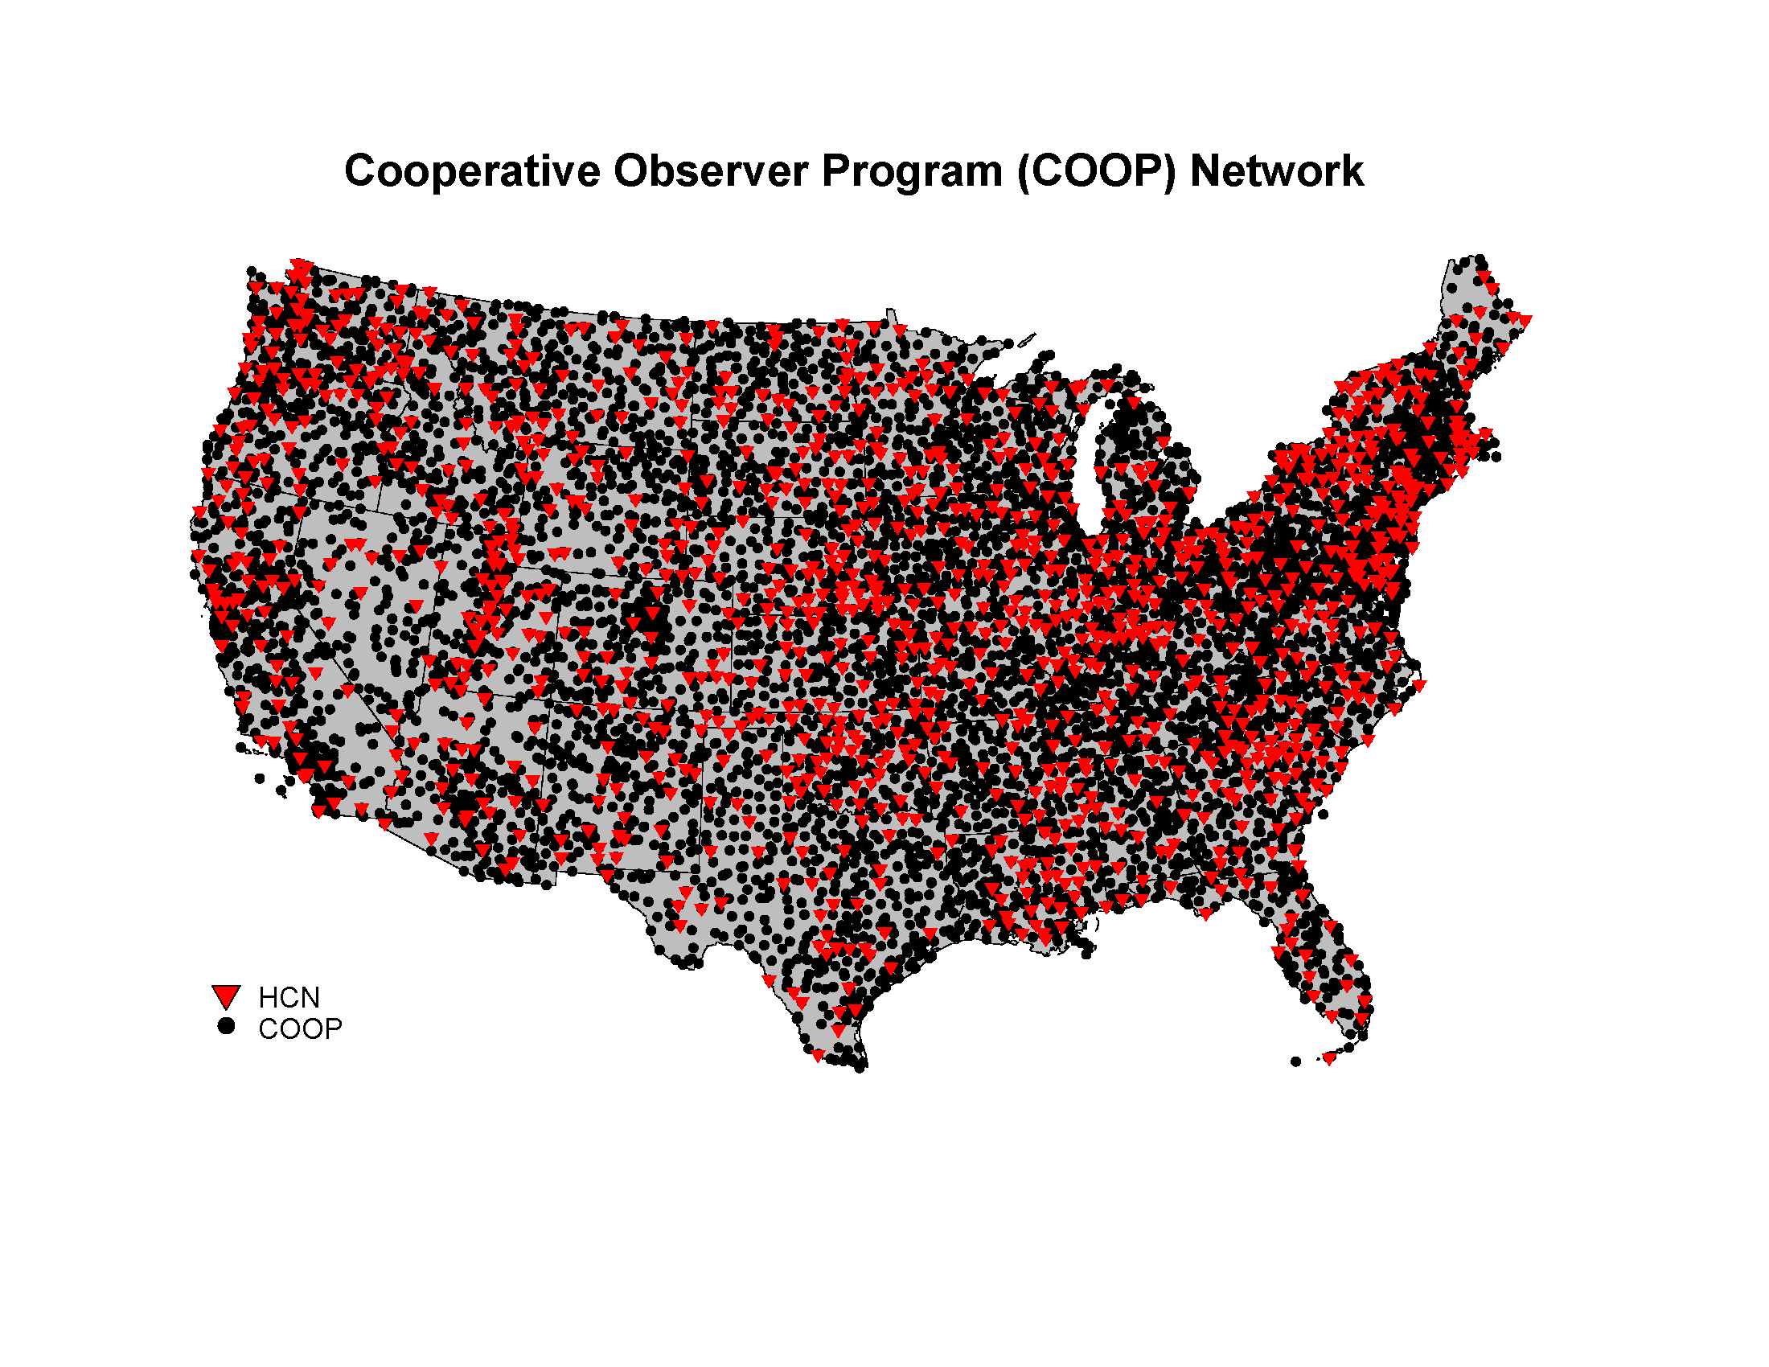

Figure : U.S. Cooperative Observer Network stations

The first development of USHCN datasets were at NOAA's NCEI in collaboration with the Department of Energy's Carbon Dioxide Information Analysis Center (CDIAC) in a project that dates to the mid-1980s (Quinlan et al. 1987). At that time, in response to the need for an accurate, unbiased, modern historical climate record for the United States, personnel at the Global Change Research Program of the U.S. Department of Energy and at NCEI defined a network of 1219 stations in the contiguous United States whose observation would comprise a key baseline dataset for monitoring U.S. climate. Since then, the U S HCN dataset has been revised several times (e.g., Karl et al., 1990; Easterling et al., 1996; Menne et al. 2009). The three dataset releases described in Quinlan et al. 1987, Karl et al., 1990 and Easterling et al., 1996 are now referred to as the USHCN version 1 datasets.

These version 1 datasets contained adjustments to the monthly mean maximum, minimum, and average temperature data that addressed potential changes in biases (inhomogeneities) in data from USHCN stations documented in NCEI’s station history archives.

The documented changes that were addressed include changes the time of observation (Karl et al. 1986), station moves, and instrument changes (Karl and Williams, 1987; Quayle et al., 1991). Apparent urbanization effects were also addressed in version 1 with a specific urban bias correction (Karl et al. 1988).

In 2007, USHCN version 2 serial monthly temperature data were released and updates to the version 1 datasets were discontinued.

Relative to the version 1 releases, production began of version 2 monthly temperature data using an expanded database of raw temperature values from COOP stations, a new set of quality control checks, and a more comprehensive homogenization algorithm. The version 2 temperature dataset and processing steps detailed description are in Menne et al. (2009) and more briefly below.

In October 2012, a revision to the version 2.0 dataset was released as version 2.5. The version 2.5 processing steps are essentially the same as in version 2.0, but the version number change reflects modifications to the underlying database as well as coding changes to the pairwise homogenization algorithm (PHA) that improve its overall efficiency. Table 1 below lists these modifications. NCEI Technical Reports GHCNM-12-01R (Williams et al., 2012a) and GHCNM-12-02 (Williams et al. 2012b) provides details regarding the PHA modifications.

## 1.10.1 The NCDC Archive

The basement of the National Climatic Data Center (NCDC) is a treasure trove of information, holding some of the first images taken by a NOAA satellite from over 50 years ago and weather observations from Thomas Jefferson in 1776! NCDC houses the largest weather and climate archive in the world and is responsible for providing access to historically valuable information from unpublished original records.

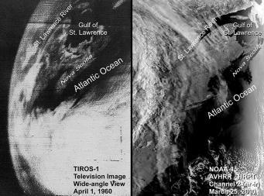

Figure 1.12: NCDC Satellite archive

Figure : NCDC Satellite archive

Records can be digital documents, photographs, audio recordings, or physical textual documents, like meteorological logbook forms. The NCDC archive stores over 97,000 boxes of physical records on-site in Asheville, North Carolina, and in Federal Records Centers. The on-site archive also contains over 130,000 reels of microfilm and almost one million pieces of microfiche. In digital format, the archive stores over 18 petabytes of data–equivalent to over seven trillion pages of standard printed text!

Data in physical formats extends from the late 1700s to the present, with the majority of data from the 20th century. These data are from [land-based stations](http://www.ncdc.noaa.gov/data-access/land-based-station-data), [ships and buoys](http://www.ncdc.noaa.gov/data-access/marineocean-data), [satellites](http://www.ncdc.noaa.gov/data-access/satellite-data), [radar](http://www.ncdc.noaa.gov/data-access/radar-data), [radiosonde weather balloons](http://www.ncdc.noaa.gov/data-access/weather-balloon-data), [climate computer models](http://www.ncdc.noaa.gov/data-access/model-data), and weather-recording volunteers. In an effort to improve understanding of the climate, many different types of data are archived and studied— data collected from [hundred-thousand-year-old tree rings](http://www.ncdc.noaa.gov/data-access/paleoclimatology-data) all the way to the latest satellite data, which are used to develop high-quality [Climate Data Records](http://www.ncdc.noaa.gov/cdr/index.html).

The largest dataset at NCDC on paper media is surface weather observations. These consist of hourly and daily observations taken at [National Weather Service](http://www.weather.gov/) (and its predecessor, the U.S Weather Bureau) stations. Other high-volume datasets on paper include U.S. Navy ship weather observations, U.S. Coast Guard observations, Weather Bureau publications, and 19th century weather journals. To improve accessibility and preservation of data on paper, microfilm, and microfiche, the NCDC archive is working to convert as many physical records as possible into digital format.

As stewards of the nation's weather and climate data, NCDC is responsible for ensuring its quality and integrity. Private industry, academia, research organizations, government, foreign institutions, media, and the public all use data from the archive. Archive experts at NCDC are dedicated to ensuring that potential users of the data can discover the data and have access to it from anywhere in the world. Their work includes improving catalogs, documentation and usability, increasing accessibility, centralizing data, and implementing policies to make data more easily searchable and discoverable for present and future generations.

## 1.10.2 NCEI

The National Centers for Environmental Information (NCEI) is the Nation's Scorekeeper in terms of addressing severe weather and climate events in their historical perspective. As part of its responsibility of monitoring and assessing the climate, NCEI tracks and evaluates climate events in the U.S. and globally that have great economic and societal impacts. NCEI is frequently called upon to provide summaries of global and U.S. temperature and precipitation trends, extremes, and comparisons in their historical perspective. Found here are the weather and climate events that have had the greatest economic impact from 1980 to 2018. The U.S. has sustained 230 weather and climate disasters since 1980 where overall damages/costs reached or exceeded $1 billion (including CPI adjustment to 2018). The total cost of these 230 events exceeds $1.5 trillion.

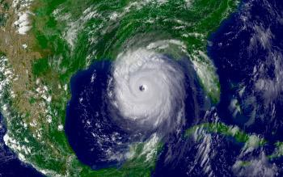

Figure 1.13: katrina-08-28-2005

Figure : katrina-08-28-2005

**2018 in Progress…**

In 2018 (as of April 6), there have been 3 weather and climate disaster events with losses exceeding $1 billion each across the United States. These events included 1 severe storm event and 2 winter storm events. Overall, these events resulted in the deaths of 34 people and had significant economic effects on the areas impacted. The 1980–2017 annual average is 6.0 events (CPI-adjusted); the annual average for the most recent 5 years (2013–2017) is 11.6 events (CPI-adjusted).

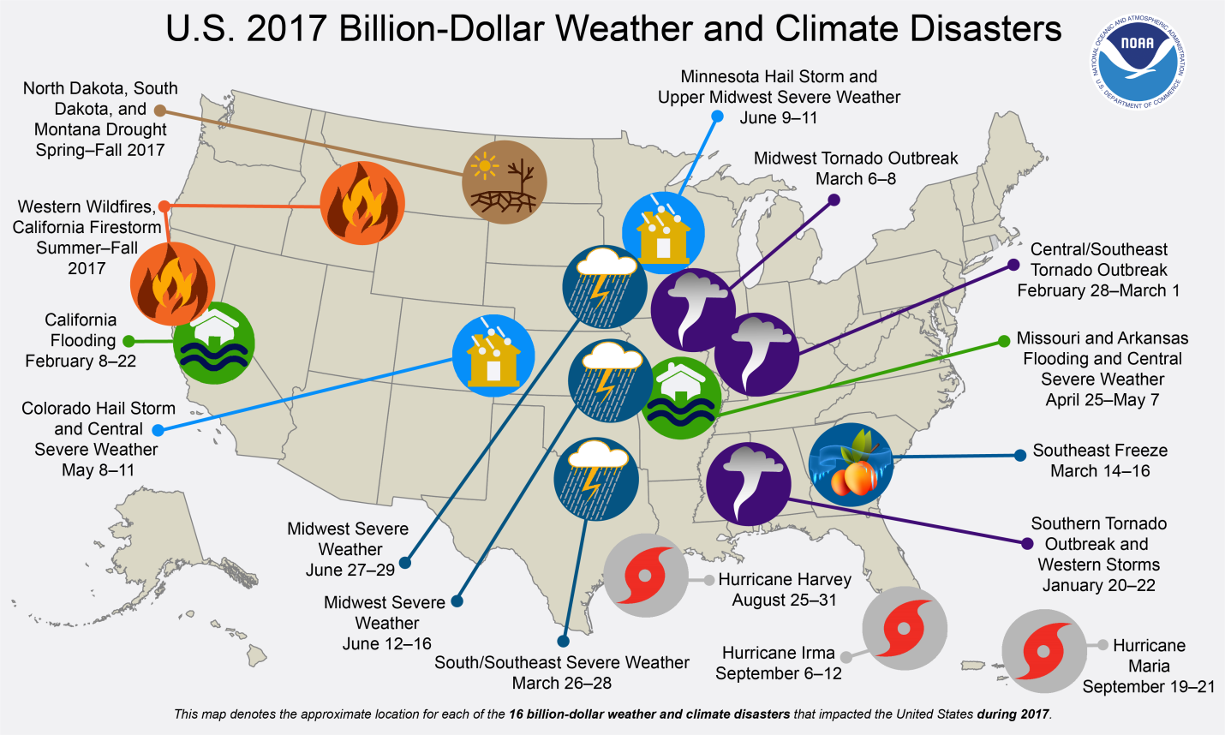

Figure : 2017-billion-dollar-disaster-map

## 1.10.3 Methodology and Data Sources

In 2012, NCEI -- then known as National Climatic Data Center (NCDC) -- reviewed its methodology on how it develops Billion-dollar Disasters. NCEI held a workshop with economic experts (May, 2012) and worked with a consulting partner to examine possible inaccuracy and biases in the data sources and methodology used in developing the loss assessments (mid-2013). This ensures more consistency with the numbers NCEI provides on a yearly basis and give more confidence in the year-to-year comparison of information. Another outcome is a published peer-reviewed article ["U.S. Billion-dollar Weather and Climate Disasters: Data Sources, Trends, Accuracy and Biases" (Smith and Katz, 2013)](https://www.ncdc.noaa.gov/monitoring-content/billions/docs/smith-and-katz-2013.pdf). This research found the net effect of all biases appears to be an underestimation of average loss. In particular, it is shown that the factor approach can result in an underestimation of average loss of approximately 10–15%. This bias was corrected during a reanalysis of the loss data to reflect new loss totals.

##### Chapter 2:

Project Scope

As previously mensioned any data related project will always go through the same five steps of devolopment as to finally reach the launch stages, and this one is no different, the steps are as follows,

* Discovery
* Data Preparation
* Model Planning
* Model Building
* Communicate Results
* Operationalize

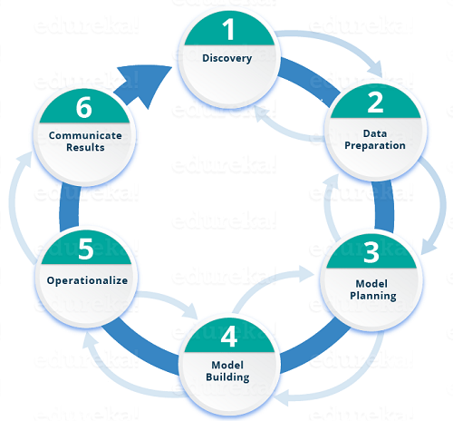

Figure : Data projects life cycle

# **2.1 Discovery**

In this phase we walk through the plemenary stages of the project in terms of creating an idea about the project stages, data, and business values.

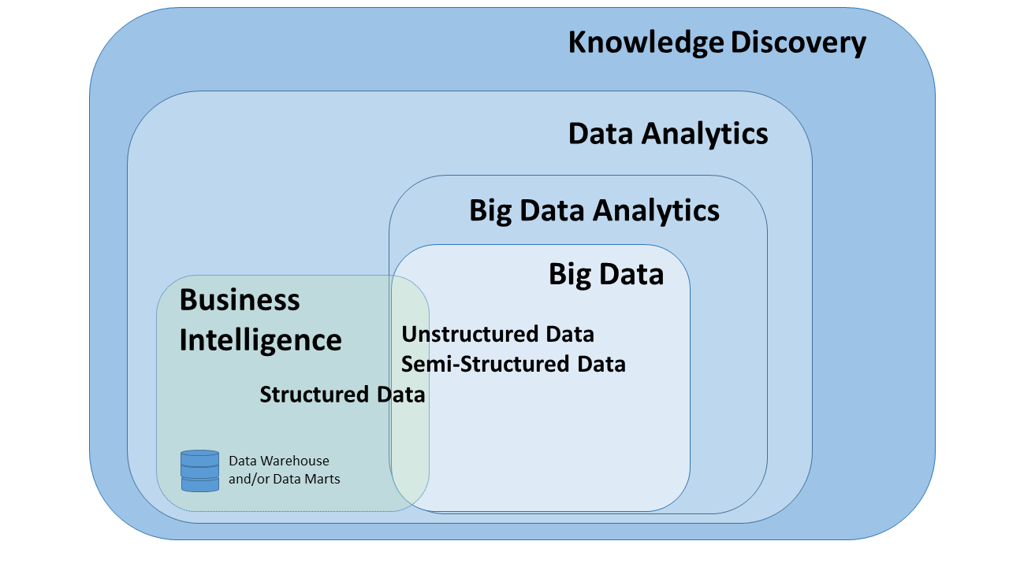

Figure : Big Data framwork

Discovery stages are well known of their un-tidiness in terms of seperating ideas, formulating structured thinking, and creating specific catagories for what needs to happen and where should it lie, however this step is usualy one of the harder ones as to its un-formulated nature, and usually as a result of too many ideas as well.

In that case it takes a skilled leader to formulate those ideas, determind what can be useful and what’s just a waste of time before starting down the path leading to model creation.

## 2.1.1 Domain knowledge

Attempting to create a model on weather analysis requires team members and mangement to have sufficient information about weather termonology and understandings to be able to comprehend future findings, researches, and eventually meaningful results.

### It starts with the termonology: Forcasting

Analyses of Weather Data    
Forecasting the weather begins by continuously observing the state of the atmosphere, the ocean, and land surface.  The World Meteorological Organization provides the framework for an evolving worldwide suite of observing systems, such as satellites, radars, and surface weather observations that aid in monitoring these conditions.  Observations from private citizens, particularly of precipitation type and severe weather, are increasingly available through social media, platforms such as the mobile Precipitation Identification Near the Ground (mPING) initiative, and through organized efforts such as the National Weather Service’s Cooperative Observer program and the Community Collaborative Rain, Hail and Snow (CoCoRaHS) network.

Although major research challenges remain, scientists have made considerable progress in developing mathematical techniques to integrate these observations into snapshots of the land surface and atmospheric state at any given time.  These analyses serve as the foundation for weather prediction on scales from individual clouds to regional severe weather events and global patterns. Analyses of current and past weather support many diverse environmental applications, including fundamental scientific investigations of the climate system.

Forecast Techniques  
For time scales on the order of a few minutes to a few hours, forecasters rely heavily on an extrapolation of current weather trends.  Such forecasts are often called “nowcasts.”  For instance, radar animations may be examined to predict the timing of a squall line while also taking into account changes in the environmental conditions with which the storm may interact. Nowcasting techniques often rely upon extrapolation, statistics, and experience-based intuition rather than sophisticated atmospheric models, yet they can be highly accurate on short timescales.

At time scales of a few hours to a month or more, numerical weather prediction (NWP) is the dominant forecasting technique. NWP, or computer-based modeling of the atmosphere, involves representing the current atmospheric state on a three-dimensional grid, applying the physical and dynamical equations that govern how the atmosphere will change in time at each grid point, and repeating this process to generate a forecast of desired length. Computer memory and processing limitations dictate the number of grid points and complexity of small-scale physical process parameterizations that can be reasonably used, with more points generally leading to a better solution.  Modern NWP models are developed and maintained in collaboration among multiple agencies and are often coupled with models of the land surface and ocean.

### ****How reliable are today’s forecasts?****

Skill, predictability, and lead time  
The skill of a forecast refers to how accurate the forecast is compared to some reference or baseline prediction, such as a forecast compared against climatology or persistence of current conditions.  The predictability of meteorological events differs based on the size and timing of the event.  Larger systems are inherently more predictable at a given lead time than are smaller ones.  Predictability also decreases as the lead time — the amount of time between the present and when the phenomenon is expected to occur —  increases.

Predictability is further limited by an incomplete representation or, at times, full understanding of the relevant physical processes, inadequate observations and methods for their incorporation into numerical model forecasts, and limitations in computational power. Nevertheless, as the examples below illustrate, advancements in all of these aspects in recent years have resulted in more skillful forecasts across diverse meteorological phenomena and forecast lead times.

### Is there any importance of this in real life?

The forecast process is often collaborative, with teams of meteorologists routinely integrating new information into the forecast as the event approaches. Increasingly, forecasters are also responsible for effectively communicating the forecast and its anticipated impacts upon life and property to various stakeholders, including the public.

The impacts of meteorological phenomena upon both life and property, whether short-lived or long-lasting in nature, are substantial:

* Nearly 90% of the emergencies declared by the Federal Emergency Management Agency are weather-related.
* More than 7000 road fatalities per year can be directly or indirectly attributed to weather.
* Approximately 70% of air traffic delays are caused by weather, at a cost of about $6 billion per year.
* Heat waves kill an average of about 175 people each year in the U.S.
* U.S. utilities save more than $150 million per year using 24-hour temperature forecasts to meet electricity demands most efficiently.
* Reducing the length of coastline under hurricane warnings involving the need for evacuations saves up to $1 million per coastal mile in evacuation and other preparedness costs.

### Forecast Terms

#### **Sky Condition**

The sky condition describes the predominant/average sky cover based on percent of the sky covered by opaque (not transparent) clouds. If a high probability of precipitation (60% or greater) is expected, then the sky condition may be omitted since it is inferred from the precipitation forecast.

#### **Temperature**

The temperature in a forecast is used to describe the forecast maximum and minimum temperature, or in some cases, the temperature at a specific time.

#### **Wind**

The wind describes the prevailing direction from which the wind is blowing with speeds in miles per hour. The wind forecast is included in the first three periods of the zone forecast.

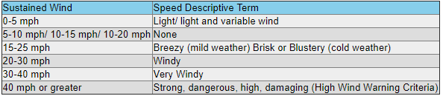

Figure : Wind termonology

#### **Precipitation Probability**

The probability of precipitation (POP), is defined as the likelihood of occurrence (expressed as a percent) of a measurable amount of liquid precipitation (or the water equivalent of frozen precipitation) during a specified period of time at any given point in the forecast area. Measurable precipitation is equal to or greater than 0.01 inches. Unless specified otherwise, the time period is normally 12 hours. The forecast area, or zone, is generally considered to be a county. NWS forecasters use such categorical terms as occasional, intermittent, or periods of to describe a precipitation event that has a high probability of occurrence (80%+), but is expected to be of an "on and off" nature.

#### **Time Periods**

 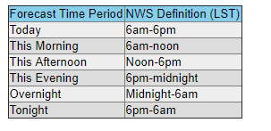

Figure 2.1.3: Time Periods termonology

Figure : Time Periods termonology

### What else is there?

A lot actually, so to formulate this process we select the most usefull and project related websites that contain such information, i.e.

* <https://www.timeanddate.com/weather/glossary.html>
* <https://www.ametsoc.org/index.cfm/ams>
* <https://www.weather.gov/bgm/forecast_terms>

 



## 2.1.2 Problem and research

Our problem identification starts after understanding world weather status, current active technologies, and weather data world’s needs. After consideration, a prediction based model was mainly proposed, meaning that it’s desired to create a model that eventually predects weather anomolies, changes, and most importantly patterns, which in turn might lead to predicting epidemics.

### Problems considered



* Classification: [Logistic regression](https://spark.apache.org/docs/2.2.0/ml-classification-regression.html#logistic-regression).
* Classification: Naive Bayes.
* Clustering: K-means.
* Collaborative filtering.
* Frequent Pattern Mining: FP-Growth

#### Classification: [Logistic regression](https://spark.apache.org/docs/2.2.0/ml-classification-regression.html#logistic-regression).

Logistic regression is a classification algorithm used to assign observations to a discrete set of classes. Unlike linear regression which outputs continuous number values, logistic regression transforms its output using the logistic sigmoid function to return a probability value which can then be mapped to two or more discrete classes.

This problem was quickly disregarded as it didn’t completely comprehend the application’s idea of “Prediction”.

#### Classification: Naive Bayes.

**Naive Bayes** is a simple, yet effective and commonly-used, machine learning classifier. It is a probabilistic classifier that makes classifications using the Maximum A Posteriori decision rule in a Bayesian setting. It can also be represented using a very simple Bayesian network. Naive Bayes classifiers have been especially popular for text classification, and are a traditional solution for problems such as spam detection.

This problem was shortlisted for a while as a possible candidate, but eventually dismissed as to the indeffinite nature of its probabilities.

#### Clustering: K-means.

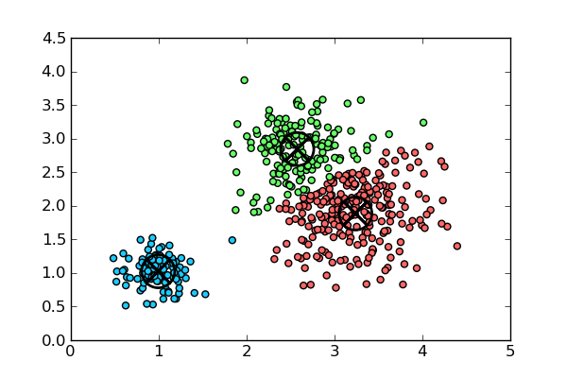

Figure 2.1.4: Data Clustering

Figure : Data Clustering

*K*-means clustering is a type of unsupervised learning, which is used when you have unlabeled data (i.e., data without defined categories or groups). The goal of this algorithm is to find groups in the data, with the number of groups represented by the variable *K*. The algorithm works iteratively to assign each data point to one of *K* groups based on the features that are provided. Data points are clustered based on feature similarity. The results of the *K*-means clustering algorithm are:

1. The centroids of the *K* clusters, which can be used to label new data
2. Labels for the training data (each data point is assigned to a single cluster)

The problem was one of the last two problems to be finally considered, its centure nature was a huge apeal as it would create noticible data points in different clusters, it was finally dismissed merely for a better problem to be considered.

#### Collaborative filtering.

Collaborative filtering (CF) is a technique used by [recommender systems](https://en.wikipedia.org/wiki/Recommender_system). Collaborative filtering has two senses, a narrow one and a more general one.

In the newer, narrower sense, collaborative filtering is a method of making automatic [predictions](https://en.wikipedia.org/wiki/Prediction) (filtering) about the interests of a user by collecting preferences or [taste](https://en.wikipedia.org/wiki/Taste_(sociology)) information from [many users](https://en.wikipedia.org/wiki/Crowdsourcing) (collaborating). The underlying assumption of the collaborative filtering approach is that if a person *A* has the same opinion as a person *B* on an issue, A is more likely to have B's opinion on a different issue than that of a randomly chosen person.

Quickly dismissed as a problem candidate, the recomendation based problem wasn’t exactly relevent.

#### Frequent Pattern Mining: FP-Growth

In Data Mining the task of finding frequent pattern in large databases is very important and has been studied in large scale in the past few years. Unfortunately, this task is computationally expensive, especially when a large number of patterns exist.

The FP-Growth Algorithm, proposed by Han in, is an efficient and scalable method for mining the complete set of frequent patterns by pattern fragment growth, using an extended prefix-tree structure for storing compressed and crucial information about frequent patterns named frequent-pattern tree (FP-tree). In his study, Han proved that his method outperforms other popular methods for mining frequent patterns, e.g. the Apriori Algorithm and the TreeProjection. In some later works it was proved that FP-Growth has better performance than other methods, including Eclat and Relim. The popularity and efficiency of FP-Growth Algorithm contributes with many studies that propose variations to improve his performance

This problem was eventually chosen as the most relevent, and result oriented to our “prediction” point of application.

### Final Decision

Careful study of the desired predictive nature of our application along with understanding each problem’s main goal, were the defining factors in choosing the problem for which our model would run, the problem was finally decided to be Frequent Pattern Mining: FP-Growth.

FP-Growth produces a list of all user specified *Frequent Items* within the database, also provides *Association Rules* that representthe frequent items’ pairing as in a form of rules, in a nutshell, it produces clever and interesting findings about the data points when compared to each other. Also provides the ability to apply new data on the model, and in turn produces the model virsion of prediction based on the rules previously mentioned.

## 2.1.3 Past experiences

Weather Analysis ideas have been discussed and implemented many times before, however, relevent projects previously discussed are at least a couple years old, the technologies and Machine Learning (ML) algorithims have been mildly improved since.

Many previous project had focused mainly on forecasting the weather, or merely understanding previously collected data, however, non has discussed the idea of using ML to predict future behaviours with the usage of past collected data.

#### Examples of past projects:

* <http://www.indiana.edu/~geog109/project/project.htm>
* <https://dl.acm.org/citation.cfm?id=1686705>

## 2.1.4 Resources

Recources vary in type, size and importance, but it’s in doubt essential for any project to have sufficient recourse to realize its goal, this is no different.

### Assessing available technology



Apache Spark has been for some times a leading cadidate to be selected as a platform for most data-based applications.

#### How does Spark relate to Apache Hadoop?

Spark is a fast and general processing engine compatible with Hadoop data. It can run in Hadoop clusters through YARN or Spark's standalone mode, and it can process data in HDFS, HBase, Cassandra, Hive, and any Hadoop InputFormat. It is designed to perform both batch processing (similar to MapReduce) and new workloads like streaming, interactive queries, and machine learning.

#### Scala vs. Python for Apache Spark

As the big data experts continue to realize the benefits of Scala for Spark and Python for Spark over the standard JVMs - there has been a lot of debate lately on “Scala vs.

Python- Which is a better programming language for Apache Spark?”. The criticism from data scientists on choosing either Scala Spark or Python Spark emphasizes on - performance, complexity of the language, integration using existing libraries and the best utilization of Apache Spark’s core capabilities.

1. **Scala vs Python- Performance**

Scala programming language is 10 times faster than [Python for data analysis](https://www.dezyre.com/data-science-in-python-online-training/36) and processing due to JVM. The performance is mediocre when Python programming code is used to make calls to Spark libraries but if there is lot of processing involved than Python code becomes much slower than the Scala equivalent code.

Python interpreter PyPy has an in-built JIT (Just-In-Time) compiler which is very fast but it does not provide support for various Python C extensions. In such situations, the CPython interpreter with C extensions for libraries outperforms PyPy interpreter.

Using Python against Apache Spark comes as a performance overhead over Scala but the significance depends on what you are doing. Scala is faster than Python when there are less number of cores. As the number of cores increases, the performance advantage of Scala starts to dwindle.

**2) Scala vs Python - Learning Curve**

Scala language has several syntactic sugars when programming with Apache Spark, so big data professionals need to be extremely cautious when learning Scala for Spark. Programmers might find the syntax of Scala for programming in Spark crazy hard at times. Few libraries in Scala makes it difficult to define random symbolic operators that can be understood by inexperienced programmers. While using Scala, developers need to focus on the readability of the code.

Python is comparatively easier to learn for Java programmers because of its syntax and standard libraries. However, Python is not an ideal choice for highly concurrent and scalable systems like SoundCloud or Twitter.

**3) Scala vs Python – Concurrency**

Scala allows developers to write efficient, readable and maintainable services without dangling the program code into an unreadable cobweb of call-backs. Python, to the contrary, does support heavyweight process forking using uwsgi but it does not support true multithreading.

When using Python for Spark, irrespective of the number of threads the process has –only one CPU is active at a time for a Python process. This helps get around with one process per CPU core but the downfall to this is, that whenever a new code is to be deployed, more processes need to restart and it also requires additional memory overhead. Scala is more efficient and easy to work with in these aspects.

**4) Scala vs Python – TypeSafety**

When programming with Apache Spark, developers need to continuously re-factor the code based on changing requirements. Scala is a statically typed language though it appears like a dynamically typed language because of the classy type inference mechanism. Being a statically typed language –Scala still provides the compiler to catch compile time errors.

**5) Scala vs Python – Ease of Use**

Scala and Python languages are equally expressive in the context of Spark so by using Scala or Python the desired functionality can be achieved. Either way the programmer creates a Spark content and calls functions on that. Python is a more user friendly language than Scala. Python is less verbose making it easy for developers to write a script in Python for Spark. Ease of use is a subjective factor because it comes down to the personal preference of the programmer.

**6) Scala vs Python – Advanced Features**

Scala programming language has several existential types, macros and implicits. The arcane syntax of Scala might make it difficult to experiment with the advanced features which might be incomprehensible to the developers. However, the advantage of Scala comes with using these powerful features in important frameworks and libraries.

Having said that, Scala does not have sufficient data science tools and libraries like Python for machine learning and natural language processing. SparkMLib –the machine learning library has only fewer ML algorithms but they are ideal for big data processing. Scala lacks good visualization and local data transformations. Scala is definitely the best pick for Spark Streaming feature because Python Spark streaming support is not advanced and mature like Scala.

#### Decision

It was decided to better use Scala as an effective programming language for our data-specific application on Spark.

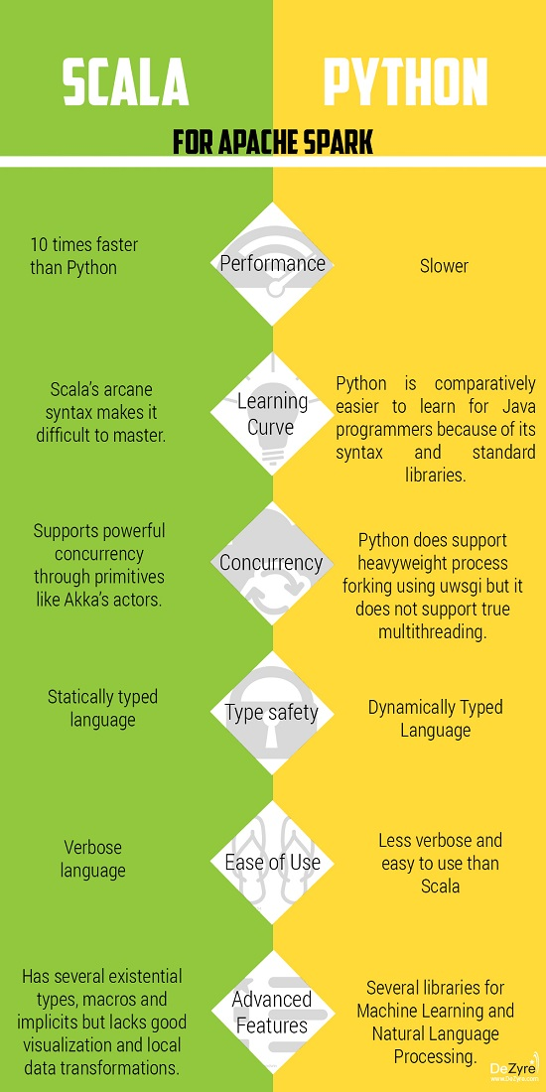

Figure : Scala vs Python

### Available data

The model data repository at NCEI contains both deep archived (offline) and online model data. They provide a variety of ways to access their weather and climate model data. The online data can be accessed using traditional access methods (web-based or FTP), or using open and distributed access methods promoted under the collaborative approach called the NOAA National Operational Model Archive and Distribution System (NOMADS).

NCEI maintains a repository of weather model datasets as well as distributed access servers to these datasets. They provide access to weather model forecast data in near real-time as well as access to historical data in the online and offline (tape archive) repositories.



The data available at NCDC is more than sufficient to create, run, and scale the model in the future.

### People for the working team

A project of this size would require 2-3 data scientists, or data experts, at least one member of Web App experties, and another for Mobile App implemintation speciality, since the members of the team are of low size, it’s understandable if a project leader is selected out of existing member rather that getting one.

### Assessing time scope

A 4-5 weeks estimated to collect ad prepare data, before creating and finalizing the model, another week for vaildating the model, a span of two weeks to create a reliable WebApp and MobileApp user interface, and finally testing before launch.

## 2.1.5 Analytics problem

As previously mentioned, the problem Frequent Pattern Mining: FP-Growth was chosen to be the selected problem fo this analytics system, however it’s importance and relevence to user weren’t discussed.

The importance lies in the need of a stable, comprehensive model to reflect on the desired results, in which we aim to predict certain behaviours or patterns in the weather changes. As for the user, it’s important to be able to easily understand and relate to the predictions resulting for the application.

## 2.1.6 Identifing Stakeholders and their interests

Understandably the indivisuals most interested in a weather analysis program, would be researchers in the relevent field, Scientist of interest to weather, and simply weather enthusiasts, but it’s fair to say the App would be of importance to all those who are resedence in areas of weather difficulties, as once the App earns its credability, it could be widely used by said indivisuals.

## 2.1.7 Pain points

All possible pain points or big hits so to speak were discussed by all team members, It was mainly identified that there would be two big points and then a possible future pain point,

* Raw data formation change, usually takes the longer time to apply as it usually takes big hits continuiously throught-out.
* Model size and possible hardware incapapbility, also from the users front, and how it would affect them.
* Time complexity, the model selected has an exponential time complexity charachteristic, it was feared that the model would basically take to much time to run.

## 2.1.8 Objectives, risks, and creteria.

It is nessesary early-on for any project for that matter to determind the work’s creteria, and what can be considered success and what can be considered flat out failture. Objectives were selected on the back of the information already formed on the App, the recomendations of the stakeholders, and other related parties,

* The App should sufficiently provide useful information, and/or predections.
* The App should have a relatively understandable size for all users types previously identified.
* Run time should be of minimal value, for e.g. below 2-min is considered fast, 2-min to 5-min is considered relativelt slow, mor than that is un-usable.

While creteria was mainly chosen on the back of the aforementioned objectives, the risks needed their own discussion, and the following was shortlisted,

* Some data attributes might not be model-used, meaning it wouldn’t be viable to correct them, or to be deamed un-usable.
* Some data types would contain too many Null values that it would be deamed un-repairable, and therefor diregarded.

## 2.1.9 Initial hypothesis

An initial hypothesis was of the essence as it provides guiding light for what looked like a shaky ride, after considerable research and discussions, it was decided that the hypothesis is based on the idea that using careful analysis, Machine Learning algorithim FP-Growth, and a sufficient amount of raw data from NCDC, it would be possible to predict weather changes, and future epidemics.

## 2.1.10 Learning the data

Getting familiar with the data is never a straight forward step, it always produce different ideas, some are diverce and some are creative, so it was necessary to take it step by step to reach a satisfactory level that would enrich all team members with the knowledge of the data formation and general overview.

### Aggregate sources

As mention before the following data sources were shortlisted to be the most useful in relation to our brand of project,

* <https://www.metoceanservices.com/>
* <https://www.ametsoc.org/index.cfm/ams/>
* <https://www.ncdc.noaa.gov/>

And the later was chosen to be our project’s only weather data source.

### Reviewing raw data

Raw data is as expected semi-structured, hard to read, and in definite need of work to be visualized.

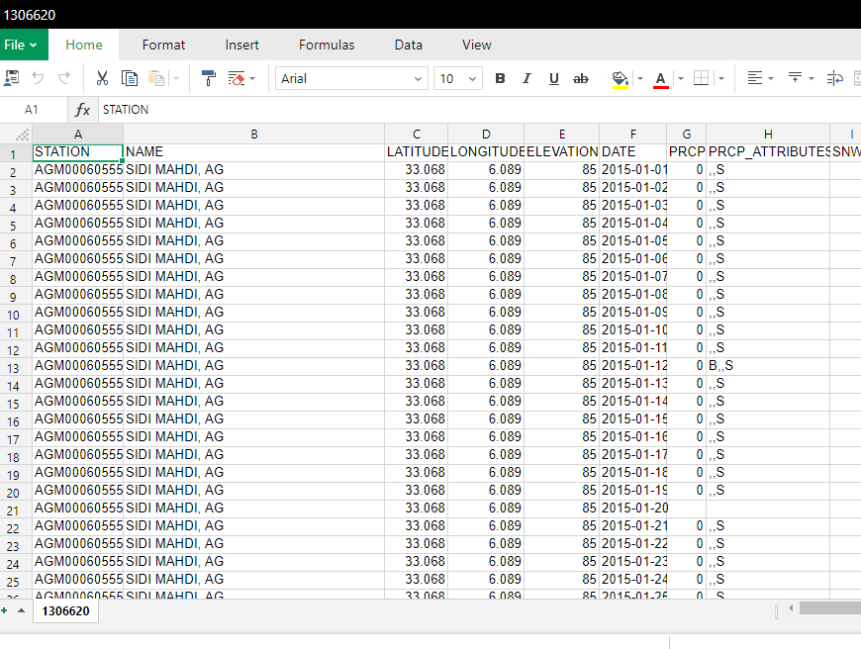

Figure : NCDC data of the Northern Africa region

## 

Figure : Data attributes of the Northern Africa region

### Data Structure

It was obvious that the data had a various DataType formate, the structure was that of a csv fie or a text file, also the data contained a lot of Nullable attributes.

### Scoping data

Some atributes like Station Name and location wasn’t going to be very useful obviously in our data selection, other data attributes like “PRCP_ATTRIBUTES”, “SNWD_ATTRIBUTES”, and “TAVG_ATTRIBUTES” were merely string format of their prospective values, so these attributes were chosen to be dismissed.

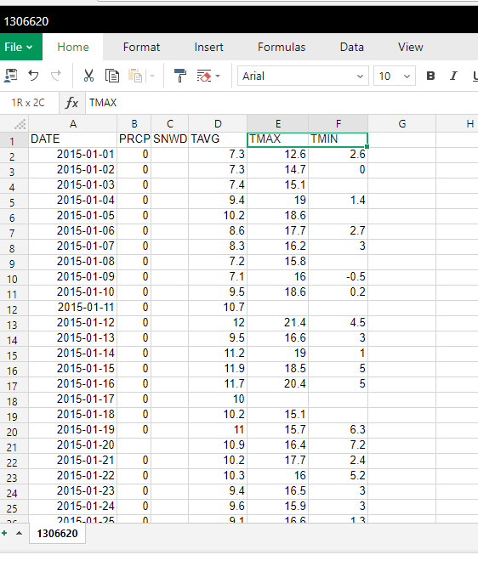

Figure : Un-usable data attributes

# 2.2 Data Preparation

Data Preparation is the process of collecting, cleaning, and consolidating data into one file or data table, primarily for use in analysis.

#### Why Prepare Data?

* Some data preparation is needed for all mining tools
* The purpose of preparation is to transform data sets so that their information content is best exposed to the mining tool
* Error prediction rate should be lower (or the same) after the preparation as before it
* Data need to be formatted for a given software tool
* Data need to be made adequate for a given method
* Data in the real world is dirty

1. incomplete: lacking attribute values, lacking certain attributes of interest, or containing only aggregate data e.g., DATE =“”
2. noisy: containing errors or outliers e.g., AWND=“-10”, PRCP=“222”
3. inconsistent: containing discrepancies in codes or names.

## 2.2.1 Performing ETL (Extract Load Transform)

ETL comes from Data Warehousing and stands for Extract-Transform-Load. ETL covers a process of how the data are loaded from the source system to the data warehouse. Currently, the ETL encompasses a cleaning step as a separate step. The sequence is then Extract-Clean-Transform-Load. Let us briefly describe each step of the ETL process.

### Extract

The Extract step covers the data extraction from the source system and makes it accessible for further processing. The main objective of the extract step is to retrieve all the required data from the source system with as little resources as possible. The extract step should be designed in a way that it does not negatively affect the source system in terms or performance, response time or any kind of locking.

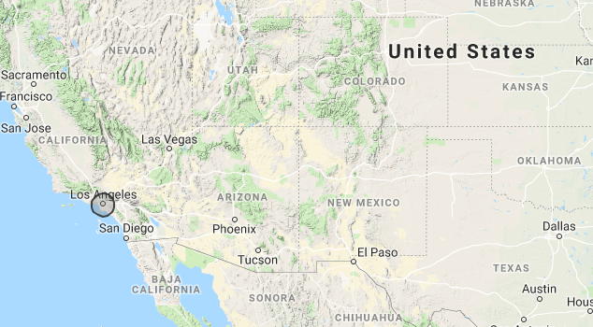

Figure 2.2.1: NCDC tringlating the area of Los Angelos

Figure : NCDC tringlating the area of Los Angelos

This was done through the NCDC mail delivery system, the data is choosen, processed and sent through to a specified e-mail.

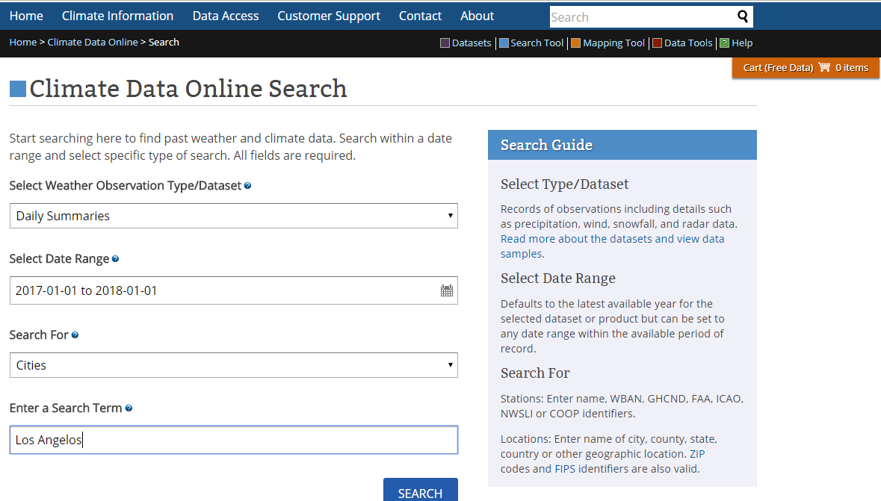

Figure : NCDC choosing a loctaion

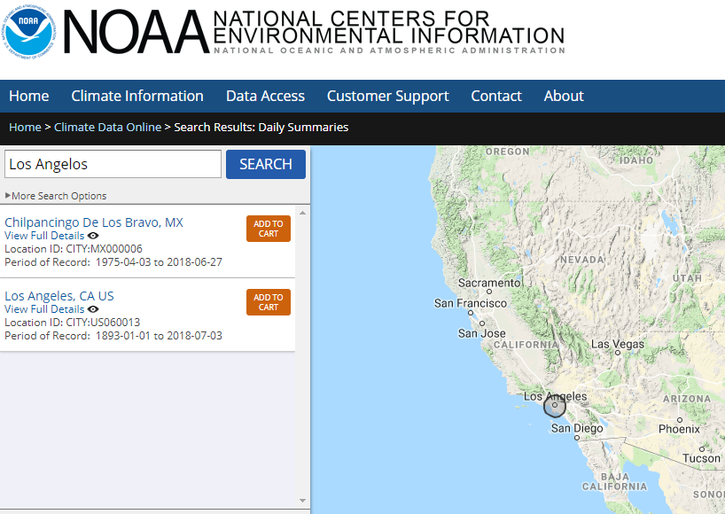

Figure : NCDC adding multible locations

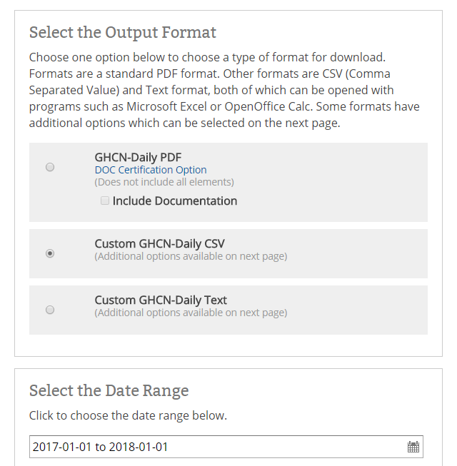There are definitely a lot of specification and disired outcome general formation to be decided, the website is well eqiped as in the following figures.

Figure 2.2.4: NCDC choosing output format

Figure : NCDC choosing output format

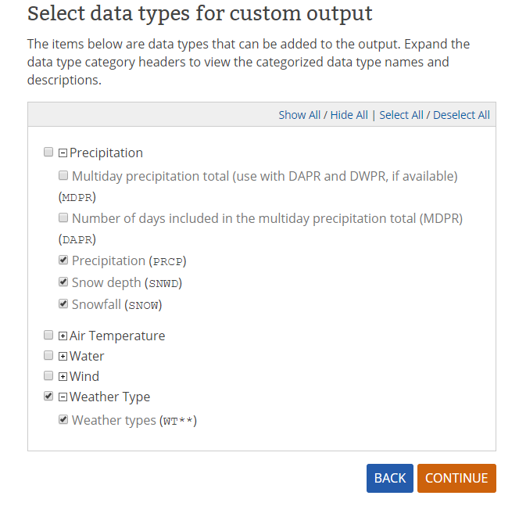

Figure 2.2.5: NCDC selecting data specifications to be extracted

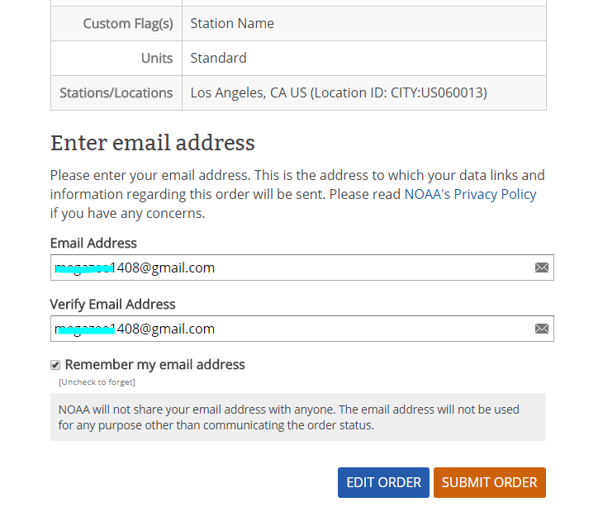

Figure 2.2.6: NCDC specifing the recieving e-mail adress

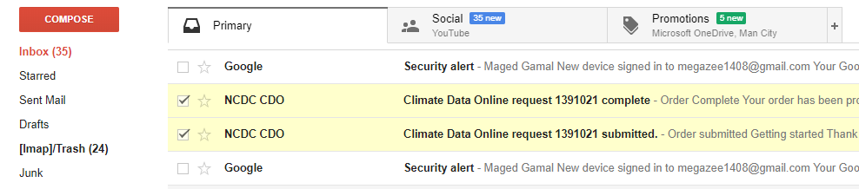

Figure : NCDC e=mail confirmation and completion



Figure : NCDC download link for ordered data

### Clean

The cleaning step is one of the most important as it ensures the quality of the data in the data warehouse. Cleaning should perform basic data unification rules, we’ll talk about this in details.

### Transform

The transform step applies a set of rules to transform the data from the source to the target. This includes converting any measured data to the same dimension (i.e. conformed dimension) using the same units so that they can later be joined. The transformation step also requires joining data from several sources, generating aggregates, generating surrogate keys, sorting, deriving new calculated values, and applying advanced validation rules.

### Load

During the load step, it is necessary to ensure that the load is performed correctly and with as little resources as possible. The target of the Load process is often a database. In order to make the load process efficient, it is helpful to disable any constraints and indexes before the load and enable them back only after the load completes. The referential integrity needs to be maintained by ETL tool to ensure consistency.

## 2.2.2 Data reduction and discretization

Obtaining reduced representation in volume but produces the same or similar analytical results, “WeatherType” is a data value spanning from 21 different columns that could have values of 0 or 1, representing the type of the weather in the specified time frame (i.e daily, weekly, monthly, et.), e.g Foggy, Drizzly, Rainy, et.

1. val newdf = data.withColumn("WT01", when(col("WT01") === "1", "Fog "))
2. .withColumn("WT03", when(col("WT03") === "1", "Thunder "))...
3. val newdf2 = (newdf.withColumn("WeatherType", concat($"WT01", $"WT02" ...

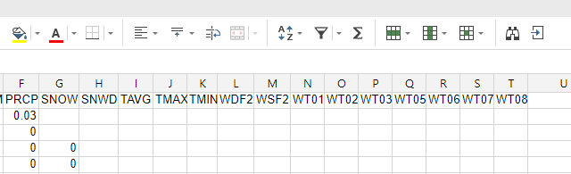

Figure : WT** transformation

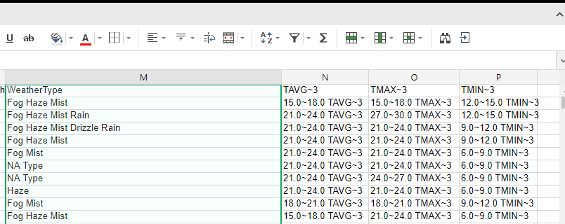

Figure : WeatherType creation

## 2.2.3 Data cleaning

Fill in missing values, smooth noisy data, identify or remove outliers, and resolve inconsistencies.

### Handling Missing Data

Data is first partition by each station, then ordered by date,

1. val w = Window.partitionBy($"STATION").orderBy($"DATE")

Most of the data provided will have Null, Nan values, handling them depends entirly on the column representation as follows;

“AWND”, “PGTM”, “WDF2”, “WSF2”, and “WeatherType” columns can’t be given a default value, or even depend on a last value provided, so handed a label “NA” that represent Not-Available,

1. val datafill = newdf4.na.fill(Map( "AWND" -> "NA", "PGTM" -> "NA",  ...

“SNOW”, “PRCP”, “SNWD”, “TMAX”, “TMIN”, “TAVG”, "TMAX~3", "TMIN~3", and "TAVG~3" Columns are replaced with most recent non-Null value.

1. val dm = datafill.withColumn("SNOW", coalesce($"SNOW", last($"SNOW", true).over(w)))

In some stations certain valuse don’t exist, or have no value for a long period of time, in which case it’ll still have a Null value, so the entire dataframe leftover Null values are are labeled “NA” since we can’t assume such favlues.

1. val dm2 = dm.na.fill("NA")

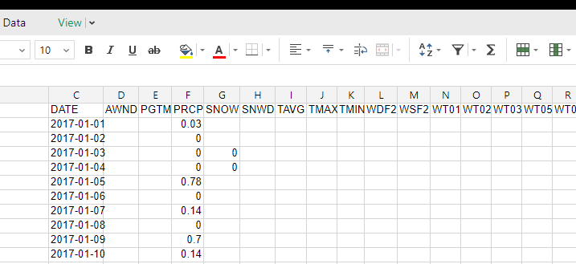

Figure : Data missing values

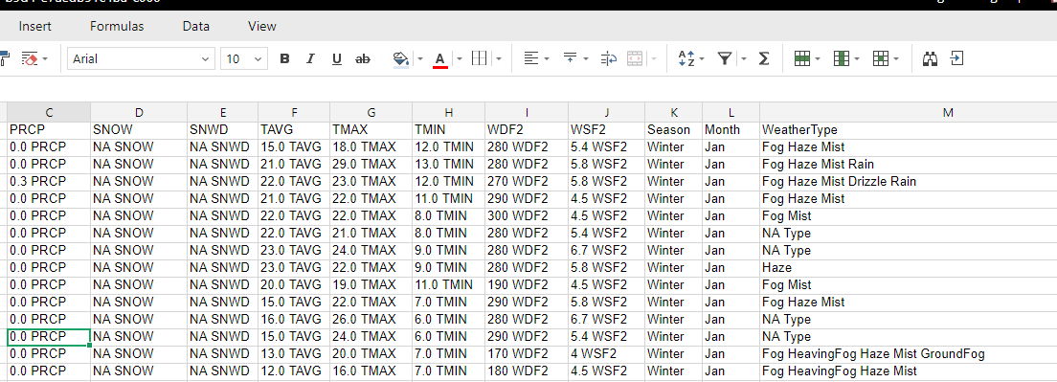

Figure : Filling data missing values

## 2.2.4 Data integration

Integration of multiple databases, data cubes, or files. This is performed with ease by making sure all databases and data sources have the save format (i.e. csv, json, et), then selecting all files in a specified folder.

1. val spark = SparkSession.builder().getOrCreate()
2. val df = spark.**read**.**option**("header","true").**option**("inferSchema","true").format("csv").**load**("data1.csv/*.csv")

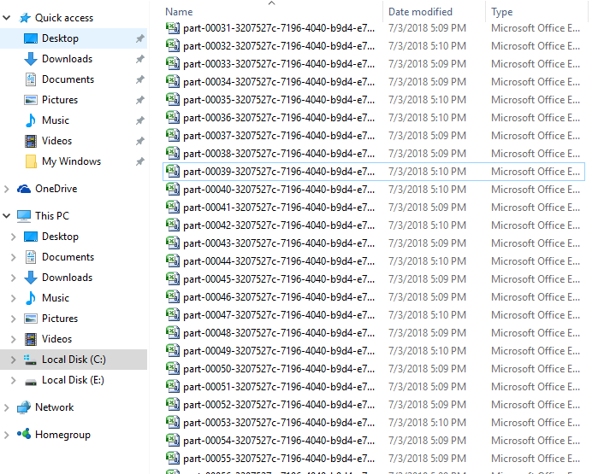

Figure : Multible source data input

2.2.5 Data transformation

Numerical columns are cast to a numeric DataType (i,e "AWND", "PRCP", "TAVG", et), column “DATE” is cast as TimeStamp DataType, then coulmn “Month” is extracted from it, which in turn is used to create column “Season”.

1. ... .withColumn("DATE", to_timestamp($"DATE", "MM/dd/yyyy"))
2. newdf3 = (newdf2.withColumn("Season", when($"Month" === 12 || $"Month" ===  1 || $"Month" ===  2, "Winter")...
3. ... .withColumn("Month",  when($"Month" === 1 , "Jan").when($"Month" === 2 , "Feb")

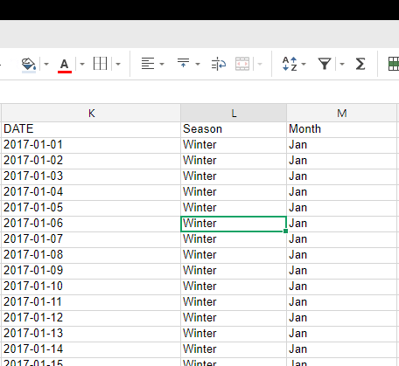

Figure : “Season” & “Month” columns

Numerical columns are rounded as follows;

“PGTM” -HHMM- rounded to every five units (minutes),

“PRCP” rounded to one decimal point,

“AWND” rounded to one decimal point,

“TMAX”, “TMIN”, “TAVG”, rounded to zero decimal point,

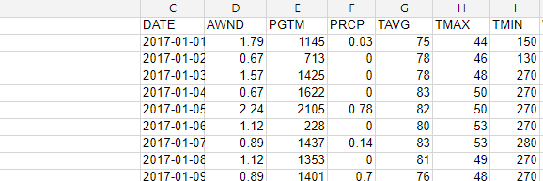

Figure : Numerical data before rounding

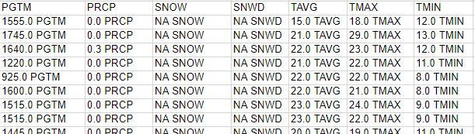

Figure : Numerical data after rounding

Three Columns are created "TMAX~3", "TMIN~3", "TAVG~3", which interpret the columns “TMAX”, “TMIN”, “TAVG” rounded to every three units (celsius)

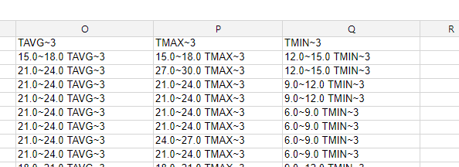

Figure : “T***~3” columns creation

All the previous changes can be considered un-nessasary, but the following are;

Since the model can mot accept two identical values in the same column, so each value is concatenated with the name of the column,

1. val df = (dm2.select(concat($"PGTM", lit(" PGTM")), concat($"PRCP", lit(" PRCP")),  ...

The model can only accept an input of one column of DataType Array, so all the columns are selected as one array named “items”,

1. val dfarr = training.select(array($"concat(PGTM,  PGTM)", $"concat(AWND,  AWND)", ... ) as "items")

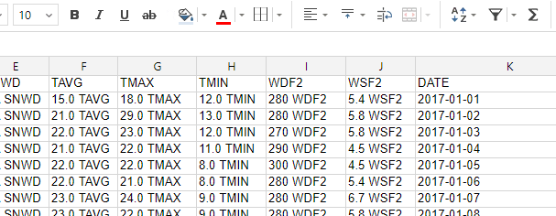

Figure : Separating data values

# 2.3 Model Planning and Selection

In this phase, the team determines the methods, techniques, and workflow it intends to follow for the subsequent model building phase. The team explores the data to learn about the relationships between variables and subsequently selects key variables and the most suitable models.

The model identification process starts on the back of what is now a well familiarized data. A prediction based model was mainly proposed, meaning that it’s desired to create a model that eventually predicts weather anomolies, changes, and most importantly patterns, which in turn might lead to predicting epidemics.

### Models considered

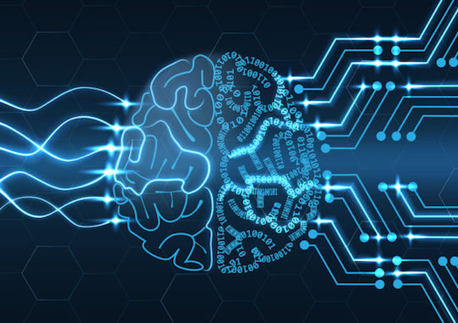

* Classification: [Logistic regression](https://spark.apache.org/docs/2.2.0/ml-classification-regression.html#logistic-regression).
* Classification: Naive Bayes.
* Clustering: K-means.
* Collaborative filtering.
* Frequent Pattern Mining: FP-Growth

## 2.3.1 Classification: [Logistic regression](https://spark.apache.org/docs/2.2.0/ml-classification-regression.html#logistic-regression).

Using this model meant that our goal would change to choosing one or two classes to be our clasification label, meaning data points will eventually just lead to a decision – a label-.

This model was refused because it doesn’t match the nature of the missing valuses in our data, plus the output leaves too much to desire.

## 2.3.2 Classification: Naive Bayes.

Using this model mwans facing almost similar issues to that of the previous model, to be specific, we would face the same issue of choosing specific attributes to shitf our goals toward.

This model was shortlisted for a while as a possible candidate, the probability method used presented a solution to our data formats, but eventually dismissed.

## 2.3.3 Clustering: K-means.

Using this model meant we could certainly satisfy our goal in finding certain patterns in our data, since the model’s very nature is to group similar data together around what is called Centroids.

The model was one of the last two problems to be finally considered, its centure nature was a huge apeal as it would create noticible data points in different clusters, but it left the desire to have predictive modelling short, even though new data can be assigned to most similar centroid which can be considered aproximate prediction, it was finally dismissed merely for a better model considered.

## 2.3.4 Collaborative filtering.

Quickly dismissed as a model candidate, the recomendation based problem wasn’t of most relevece to our predictive-minded model.

## 2.3.5 Frequent Pattern Mining: FP-Growth

The FP-Growth Algorithm is an efficient and scalable method for mining the complete set of frequent patterns by pattern fragment growth, using an extended prefix-tree structure for storing compressed and crucial information about frequent patterns named frequent-pattern tree (FP-tree). In his study, Han proved that his method outperforms other popular methods for mining frequent patterns, e.g. the Apriori Algorithm and the TreeProjection. In some later works it was proved that FP-Growth has better performance than other methods, including Eclat and Relim. The popularity and efficiency of FP-Growth Algorithm contributes with many studies that propose variations to improve his performance.

The model simply presented everything desired in our latest hypothesis, the model would produce a set of data points that are most frequent, then the model would process said items finding patterns withen their frequency, and in turn produce certain rules based on a level of confidance specified.

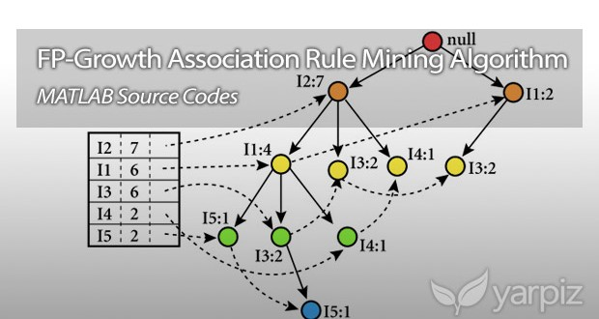

Figure : FP-Growth Model

## 2.3.6 Technique and business value

Using FP-Growth model as an implemintation of the selected predictive model meant that this App’s technique has already set into motion, the technique being a data mining algorthim to output relations between data point and their respective meanings, before appling said model on similar up-to-date data, resulting in a predictive result.

This technique is well set on the way of achieving the business value determind from the beginning, the value being producing a predictive model that can be applied on the desired data producing attribute predictions based on a number of rulkes set by the model with level of confidence set by the user.

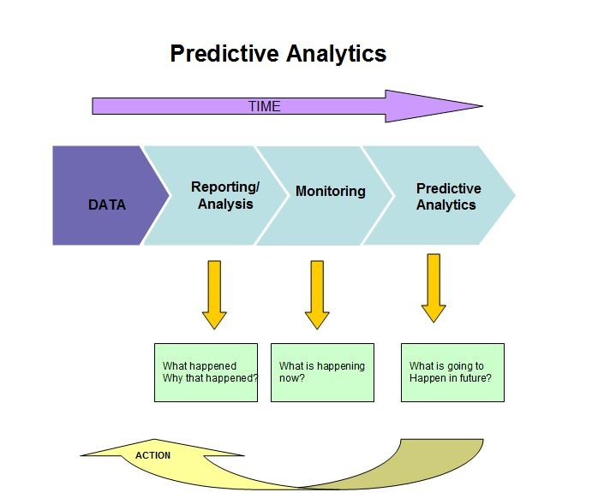

Figure : Predictive Analysis

# 2.4 Model Building

Building an accurate [predictive model](https://www.datascience.com/resources/white-papers/executives-guide-to-predictive-data-modeling) is a multifaceted process that often requires input from business stakeholders and data scientists alike. To ensure we can scale the results of our model created by the data science team, We have to take a step back, review our current state of where have we reached as to be sure that we’re correctly following the model building steps, here is a review.

### Create a hypothesis

Key performance indicators must be used to establish what our model should predict and how. That way, everyone’s on the same page about how the results will be used to influence operations in our business from the very beginning.

This was already agreed upon with an initial hypothesis that matched the stakeholders’ ideas along with the team’s ideaof the model.

### Load and transform relevant data

The next step is to collect the data that is relevant to our hypothesis and transform it to fit the model’s framework. Making the data accessible to our data scientists would require the expertise of a [data engineer](https://www.datascience.com/blog/data-science-is-a-team-sport-analytics) to ensure it’s aligned with the technical requirements of the target database. Once that’s completed, our data scientists are ready to split the data into two groups: one for training or building the model and another for testing the accuracy of its prediction.

In this step we’ve already extracted our data from the NCDC servers, after choosing the areas we should explore as in a first step. The data is already loaded and ready to be transformed.

### Identify features

[Feature engineering](https://www.datascience.com/blog/feature-engineering-for-churn-modeling) allows data scientists to tailor the model to accurately represent key patterns in the business. It involves combining raw data into categories at the appropriate level of granularity, such as amount of daily customer spending or day of the week a purchase was delivered. Feature engineering is an important part of cleaning data because it greatly reduces noise and can even address problems with sparse data. That means the model will have an easier time navigating missing values and outliers to more efficiently learn relationships in your data.

In our model the features discussed and decided to be implemented had a huge a success, such features like “WeatherType”, “Season”, “PRCP”, et.

### Building the model

Next, our data scientists selects a [machine learning algorithm](https://www.datascience.com/blog/predictive-churn-modeling-challenges) or statistical methodology that suits the data, use case, and available computational resources. Many data scientists choose to build and test multiple modeling methodologies with the intention of moving forward only with the best fit. Testing the accuracy of each model involves introducing the testing set and comparing the outputted predictions against the actual historical results.

It’s safe to say that this was the next step to go with some of it’s details already covered, such as choosing the model to be used and setting the data to match it, our next step is to split the data and start building.

### Evaluate the model

Simply testing whether our model can accurately predict outcomes within the reserved training data is not enough to be confident that it will perform well in a real-life setting. That’s where validation comes in. This involves techniques like cross validation and receiver operating characteristic (ROC) curve analysis to verify that the model will generalize well to brand new data. Choosing an algorithm that’s interpretable rather than a black box makes it easier to evaluate the resulting model. That’s because this gives your data scientists the power to look under the hood of the model itself and gain an understanding of how it arrives at its results.

### Deploy the model

Once the model appears to be performing satisfactorily, we can deploy it into production. This is usually done in one of two ways. Traditionally, the model is turned over to engineers to translate into a production stack language to prepare for deployment into the production environment. Alternatively, setting up infrastructure that empowers data scientists to [deploy models](https://www.datascience.com/platform/productionize) on their own as APIs is an option that’s gaining popularity because it eliminates lags between data science and engineering teams and gets results in front of decision makers faster.

### Monitoring the model

The process doesn’t stop once the model is deployed — we must continue to track performance over time and make adjustments as needed. A successful model will inform improvements in your business that may introduce feedback loops in your data. For that reason, retraining may be necessary to ensure the model keeps up with these evolutions.

## 2.4.1 Spliting the data

The data is split into two sections now, the “training” section and the “testing” section, to illustrate,

* **training set**—a subset to train a model.
* **test set**—a subset to test the trained model.

You could imagine slicing the single data set as follows:

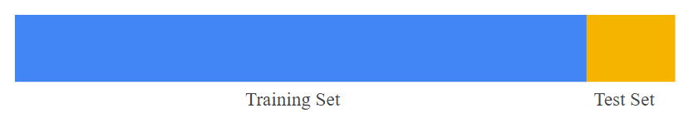

Figure : Data splitting illustration

### Slicing a single data set into a training set and test set.

Make sure that your test set meets the following two conditions:

* Is large enough to yield statistically meaningful results.
* Is representative of the data set as a whole. In other words, don't pick a test set with different characteristics than the training set.

Assuming that our test set meets the preceding two conditions, our goal is to create a model that generalizes well to new data. Our test set serves as a proxy for new data. For example, consider the following figure. Notice that the model learned for the training data is very simple. This model doesn't do a perfect job—a few predictions are wrong. However, this model does about as well on the test data as it does on the training data. In other words, this simple model does not overfit the training data.

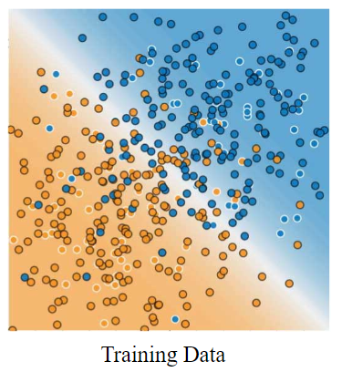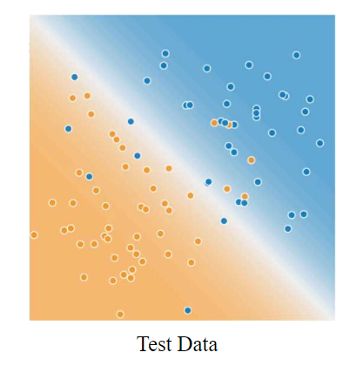

### ****Validating the trained model against test data.****

**Never train on test data.** If you are seeing surprisingly good results on your evaluation metrics, it might be a sign that you are accidentally training on the test set. For example, high accuracy might indicate that test data has leaked into the training set.

For example, consider a model that predicts whether an email is spam, using the subject line, email body, and sender's email address as features. We apportion the data into training and test sets, with an 80-20 split. After training, the model achieves 99% precision on both the training set and the test set. We'd expect a lower precision on the test set, so we take another look at the data and discover that many of the examples in the test set are duplicates of examples in the training set (we neglected to scrub duplicate entries for the same spam email from our input database before splitting the data). We've inadvertently trained on some of our test data, and as a result, we're no longer accurately measuring how well our model generalizes to new data.

### Scala representation

The data is split in the form of an array holding two DataFrame DataType by the name of (training, testing), a random split is used to make sure the data is fairly and subjectively split, we used a specific “seed” only for the purpose of getting a consistant data split should the split happen more than once on the same dataSet.

1. val Array(training, testing) = df.randomSplit(Array(0.7, 0.3), seed = 12345)

## 2.4.2 Fitting the model and user inputs

Model fitting is a procedure that takes two steps:

First you need a function that takes in a set of parameters and returns a predicted data set, along with the built model that is to be fit on the desired data.

1. val fpgrowth = new FPGrowth().setItemsCol("items").setMinSupport(supp).setMinConfidence(conf)

In this case the “supp” and “conf” parameters are the user’s inputs reflecting on Minimum Support, and Minimum Confidance parameters respectively, the model is prepared as to recieve an input that has a single column attribute of the name “items”, the FP-Growth model is created and saved in a parameter “fpgrowth”.

The model is then fit on the previously cleaned and normalized data.

1. val model = fpgrowth.fit(dfarr)

## 2.4.3 Creating the Frequent ItemSets

A frequent itemset is an itemset whose support is greater than the afore-mentioned support selected by the user.

Since the data originaly contained “NA” values, these values are of no-use as a result but were mandatory to run the model, so it’s only logical that we filter them from the results,

1. val fifiltered = fi.filter("items not like 'NA %' and items not like '%NA %' ")

Frequent Itemsets are then generated, but their format has to be changed from an Array Datatype to a DataFrame DataType, valuse are seperated with the operator “ : ”,

1. val fi = model.freqItemsets.withColumn("items", concat_ws(" : " , $"items"))

The resulting DataFrame can easily get transformed into a viewable form, (i.e .json, .csv, et)

1. fifiltered.coalesce(1).write.format("com.databricks.spark.csv").option("header", "true")
2. .save("fiTestUSData.csv"))

## 2.4.5 Creating the Association Rules

Association rules are if/then statements that help uncover relationships between seemingly unrelated data in a [relational database](https://searchsqlserver.techtarget.com/definition/relational-database) or other information repository.

An association rule has two parts, an antecedent (if) and a consequent (then). An antecedent is an item found in the data. A consequent is an item that is found in combination with the antecedent.

Association rules are created by analyzing data for frequent if/then patterns and using the criteria *support* and *confidence* to identify the most important relationships*.* *Support* is an indication of how frequently the items appear in the database. *Confidence* indicates the number of times the if/then statements have been found to be true.

Since the data originaly contained “NA” values, these values are of no-use as a result but were mandatory to run the model, so it’s only logical that we filter them from the results,

1. val arfiltered = (ar.filter(  "consequent not like 'NA %' and consequent not like '%NA %' ")
2. .filter(  "antecedent not like 'NA %' and antecedent not like '%NA %' "))

Association Rules are then generated, but their format has to be changed from an Array Datatype to a DataFrame DataType, valuse are seperated with the operator “ : ”,

1. val ar = (model.associationRules.withColumn("antecedent", concat_ws(" : " , $"antecedent"))
2. .withColumn("consequent", concat_ws(" : " , $"consequent")))

The resulting DataFrame can easily get transformed into a viewable form, (i.e .json, .csv, et)

1. arfiltered.coalesce(1).write.format("com.databricks.spark.csv").option("header", "true")
2. .save("arTestUSData.csv"))

## 2.4.6 Transforming new data

Transforming is applying “New data” to the ready model, said data can actually be either the “testing” data that was previusly split from the original data, or it could be a complete new set of data that is intended to generate certain or predictions on.

First it’s nessasary to differ between new data and testing data, so the “testing” data is set as the default value and can easily change should the user specify new data.

1. var dftr = testing.**drop**("PRCP")
2. if (flag == **true**){
3. dftr = spark.**read**.**option**("header","true").**option**("inferSchema","true").format("csv"). **load**("input/data/*.csv")
4. dftr = formalize(dftr)
5. }

If the user uses new data it’s likely to be completely raw as from the NCDC, so a lot of work needs to be done as to transform the new data into the specific-driven form that the model is using, thus the function “formalize()” is created.

### “formalize()” the function

The function is general to transform any raw data into the same form used to create the model in the first place, and here is how.

A UserDefinedFunction(UDF) is created to check if a certain column exist in a DataFrame, returning a True or False value.

1. def hasColumn(df: DataFrame, path: String) = Try(df(path)).isSuccess

Then the “formalize()” function is created taking an input of a raw DataFram DataType, and output a DataFrame DataType on the desired format.

1. def formalize(newdata: DataFrame): DataFrame = {

The same data cleaning, and normalizing steps as mentioned before are applied on the input data, and the new DataFrame is returned.

### Filtering and output

A transform method can only be applied on an DataFrame of Array DataType as it was to fit the model in the first place, so the resulting dataFrame is changed to the specified type as follows.

1. val datatr = dftr.**select**(array(dftr.columns.map(df(_)) : _*) **as** "items")

Since the data originaly contained “NA” values, these values are of no-use as a result but were mandatory to run the model, so it’s only logical that we filter them from the results,

1. val filteredtr = (transform.filter(  "prediction not like '' and prediction not like 'NA %' and prediction not like '%NA %'")
2. .filter(  "items not like '' and items not like 'NA %' and items not like '%NA %'"))

Then the new data is transformed.

1. val tr = (model.transform(dfarrtr).withColumn("items", concat_ws(" : " , $"items"))
2. .withColumn("prediction", concat_ws(" : " , $"prediction")))

# 2.5 Comunicate results

## 2.5.1 Creating web UI

Every SparkContext launches a web UI, by default on port 4040, that displays useful information about the application. This includes:

* A list of scheduler stages and tasks
* A summary of RDD sizes and memory usage
* Environmental information.
* Information about the running executors

But this standard interface doesne’t contain any user interactive functionaity , So we developed an enhancement for this UI to make it easy for any user for Spark to enter his data and show the results on a better way.

These endpoints have been strongly versioned to make it easier to develop applications on top. In particular, Spark guarantees:

* Endpoints will never be removed from one version
* Individual fields will never be removed for any given endpoint
* New endpoints may be added
* New fields may be added to existing endpoints
* New versions of the api may be added in the future as a separate endpoint (eg., api/v2). New versions are *not* required to be backwards compatible.
* Api versions may be dropped, but only after at least one minor release of co-existing with a new api version.

### Event Triggered Systems:

Kafka is used for building real-time data pipelines and streaming apps. It is horizontally scalable, fault-tolerant, wicked fast, and runs in production in thousands of companies.

kafka Streams is a client library for building mission-critical real-time applications and microservices, where the input and/or output data is stored in Kafka clusters.

Kafka Streams combines the simplicity of writing and deploying standard Java and Scala applications on the client side with the benefits of Kafka's server-side cluster technology to make these applications highly scalable, elastic, fault-tolerant, distributed, and much more. This [quickstart example](http://kafka.apache.org/11/documentation/streams/quickstart) will demonstrate how to run a streaming application coded in this library.

### Web Interface and Framework:

#### [Web Server Configuration](https://laravel.com/docs/5.6#web-server-configuration), Apache

Laravel includes a public/.htaccess file that is used to provide URLs without the index.phpfront controller in the path. Before serving Laravel with Apache, be sure to enable the mod_rewrite module so the .htaccess file will be honored by the server.

If the .htaccess file that ships with Laravel does not work with your Apache installation, try this alternative:

Options +FollowSymLinks

RewriteEngine On

RewriteCond %{REQUEST_FILENAME} !-d

RewriteCond %{REQUEST_FILENAME} !-f

RewriteRule ^ index.php [L]

### Installing Spark Standalone to a Cluster

To install Spark Standalone mode, you simply place a compiled version of Spark on each node on the cluster. You can obtain pre-built versions of Spark with each release or [build it yourself](https://spark.apache.org/docs/latest/building-spark.html).

### Starting a Cluster Manually

You can start a standalone master server by executing:

./sbin/start-master.sh

Once started, the master will print out a spark://HOST:PORT URL for itself, which you can use to connect workers to it, or pass as the “master” argument to SparkContext. You can also find this URL on the master’s web UI, which is [http://localhost:8080](http://localhost:8080/) by default.

Similarly, you can start one or more workers and connect them to the master via:

./sbin/start-slave.sh <master-spark-URL>

Once you have started a worker, look at the master’s web UI ([http://localhost:8080](http://localhost:8080/) by default). You should see the new node listed there, along with its number of CPUs and memory (minus one gigabyte left for the OS).

## 2.5.2 Creating Mobile UI

The Android Runtime (ART) already supports developing applications using Scala, as evidenced by this [Scala IDE article on Android development](http://scala-ide.org/docs/tutorials/play/index.html).

iOS, however, has no built-in JVM support. Luckily, we can leverage multiple community efforts here:

1. Use [RoboVM](http://robovm.com/), an ahead-of-time (AOT) compiler and library for developing iOS applications using Java.
2. Use [Scala+LLVM](http://greedy.github.io/scala-llvm/) to compile Spark’s Scala code into LLVM bytecode. Given Apple’s strong stand behind the LLVM project, we believe this can achieve the highest level of performance.
3. Since [Swift looks very similar to Scala](https://leverich.github.io/swiftislikescala/), we can create a project to automatically translate Scala source code into Swift, and then build the iOS package using XCode.
4. Use [Scala.js](http://www.scala-js.org/) to compile Spark into JavaScript, and execute Spark in the Nitro JavaScript engine (Safari).

Option 4 is preferred because not only does it support iOS, but also all platforms using a single package. On iOS and Android, Spark can be executed by the JavaScript engines. On servers, Spark can be executed in Node.js.

### Performance Optimizations

JavaScript engines are one of the hottest areas of innovation, and thus we fully expect JavaScript engines to improve their performance rapidly. However, mobile JavaScript engines seem to lag behind their desktop variants. In particular, there appears to be no SIMD support for mobile JavaScript.

For parts of Spark that might benefit tremendously from SIMD, such as low level matrix operations, we can selectively rewrite those parts to generate LLVM bytecode.

### Networking and Wire Protocol

Spark’s network transport builds on Netty, which in turn relies on java.nio or Linux epoll. Android ART appears to support java.nio out of the box, but we might need to rewrite Netty to use kqueue on iOS. Additionally, it is unclear whether low-level networking primitives such as zero-copy can be exposed in JavaScript. We will need to work more closely with Apple and Google to improve networking support in mobile JavaScript.

A viable alternative is to leverage [grpc](http://www.grpc.io/), an open-source high performance RPC library developed by Google. grpc provides out of the box support for all common platforms (Java, Objective C, etc) using HTTP/2.

Given the focus on debuggability, JSON should be the preferred wire serialization protocol over any existing binary formats.

### True Locality Scheduling and DAGScheduler

To better support local, social, and mobile features of Spark, we change the locality field of RDDs to GPS coordinates, and locality scheduling can be refactored to support true locality that was never possible on servers.

In order to maintain source compatibility, we keep the old interface, and introduce a new true locality interface.

class RDD {

@deprecate("2.0", "use getPreferredTrueLocations")

def getPreferredLocations(p: Partition): Seq[String]

/**

* Returns the preferred locations for executing task on partition

* p. Concrete implementations of RDD can use this to enable

* locality scheduling.

*/

def getPreferredTrueLocations(p: Partition): Seq[LatLong]

}

The DAGScheduler needs to be updated to compute the geographical proximity of executors.

### Extending TaskContext to the Mobile Platform

The TaskContext provides the contextual information for Spark tasks (e.g., job IDs, attempt IDs, etc.). While this was sufficient for running on server, the mobile platform has many other contextual information like GPS location, ongoing calls, etc. Such contextual information may be useful to optimize the processing of tasks without affecting the user experience of the smartphone/tablet user. For example, if a phone call is active, a new task may be paused until the call is over so that the call quality is not affected.

### Basic Engine on iPhone and Androids

We have already built a few proof-of-concepts using iPhones to better understand the complexities of the mobile platform. Here are some screenshots from our prototype.

The screenshot at the beginning of the blog post shows a [Spark Streaming](https://databricks.com/glossary/what-is-spark-streaming)NetworkWordCount example running on an iPhone. It is receiving data using sockets from a server running on Amazon EC2. We are also prototyping it on Android. Here is some early screenshots on the Android device emulator.

### Prototyping Machine Learning Application

In real-world machine learning, labels are always hard and expensive to obtain. This won’t be an issue with Spark on Mobile. In the pipeline API for machine learning, we will provide a transformer that produces human tags.

tagger = HumanTagger(tags=[“spam”, “ham”], retries=10)

labeled = tagger.transform(images)

model = LogisticRegression().fit(labeled)

During transformation, images are displayed along with possible tags and users choose the correct tag for each image. To make sure the transformation is fault tolerant, we will randomize the ordering and retry 10 times for each record. Yes, RDDs are always deterministic

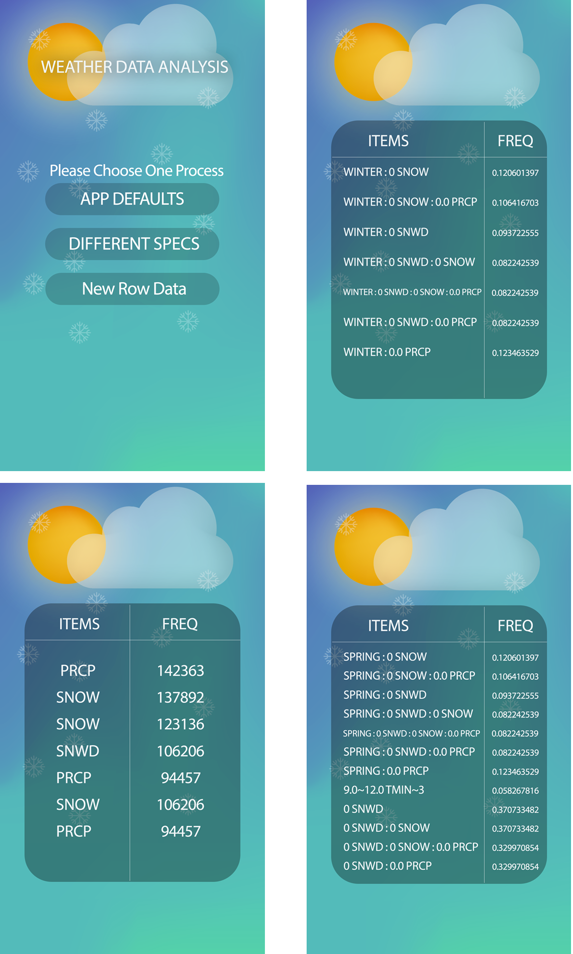

Figure : Mobile App ScreenShots

##### Chapter 3:

##### Business Domain

# 3.1 Introduction

Using Big Data has been crucial for many leading companies to outperform the competition. In many industries, new entrants and established competitors use data-driven strategies to compete, capture and innovate. In fact, you can find examples of Big Data usage in almost every sector, from IT to healthcare.

When it comes to healthcare, data pioneers have been analyzing the outcomes of pharmaceuticals. Companies have focused on discovering the risks and benefits that were not clear during initial clinical trials. Big Data can lead to a better analysis of the trials, and help predict outcomes. Some other early adopters of the concept have been using data from the sensors embedded in various products, ranging from industrial goods to children’s toys. This helps the companies determine how products are used in the real world. With such knowledge, it becomes easier to create new services and design future products.

## 3.1.1 enterprise information management

According to experts, Big Data can create a lot of new growth opportunities. It can even give rise to a new category of businesses, such as the ones that analyze and aggregate industry data. Most of these companies will be sitting in the middle of large information flows about services and products, suppliers and buyers, consumer intent and preferences, and more. Companies across industries should start building their Big Data capabilities aggressively.

In addition to the broad scale of big data, the high frequency and real time nature of data are crucial. For instance, the ability to estimate metrics, including consumer loyalty, was previously handled retrospectively. With Big Data, such practices are being used more extensively. This adds a lot to the power of prediction. Similarly, high frequency allows businesses to test theories in real time.

Besides these general benefits, Big Data helps a business organization in many different ways. Currently, Big Data is used in both the public and private sector. In the next section of the post, we’ve discussed the most important benefits of Big Data.

## 3.1.2 Dialogue with consumers

These days, consumers are smart, and understand their priorities. Before making a purchase, consumers look around and compare different options. They even talk to businesses through social media channels, and demand special treatment. In fact, most customers want to be thanked for buying products from a company.

Big Data allows a business organization to profile such customers in a far reaching manner. This allows a business to engage in real time, one-on-one conversation with consumers. In tough competitive times, this isn’t a luxury. You need to treat customers how they want.

A good example is about a customer entering a bank. When a customer enters the establishment, the clerk can use Big Data to check his or her profile in real time. The clerk can learn about the customer’s preferences and desires. This allows him to advise relevant products and services to the customer.

Big Data also plays an important role in integrating physical and digital shopping spheres. An online retailer can easily suggest an offer on the mobile carrier. This can be done on the basis of a consumer inclined toward increased social media usage.

## 3.1.3 Re-Develop Products

Big Data is one of the best ways to collect and use feedback. It helps you understand how customers perceive your services and products. Thus, you’re able to make necessary changes, and re-develop your products. When you analyze unstructured social media text, it allows you to uncover general feedback from your customers. You can even disintegrate the feedback in various geographical locations and demographic groups.

In addition to this, Big Data allows you to test numerous variations of high end computer-aided designs within seconds. For instance, you can gather information about lead times, material affect costs, performance and more. It allows you to raise the productivity and efficiency of various production processes.

## 3.1.4 Perform risk analysis

Success depends on a lot of different factors. It’s not just about how you run the company. Economic and social factors play an important role to determine your accomplishments. Since Big Data leads to predictive analytics, it allows you to analyze and scan social media feeds and newspaper reports. Thus, you can permanently keep up with speed on latest trends and developments in the industry.

## 3.1.5 Data safety

Big Data tools allow you to map the entire data landscape across the company. This allows you to analyze all kinds of internal threats. With this information, you can keep the sensitive information safe. It’s protected in an appropriate manner, and stored according to regulatory requirements.

Due to this, most industries have been focusing on Big Data to ensure data safety and protection. It’s even more important in organizations that deal with financial information, credit and debit card information, and other such practices.

## 3.1.6 Create new revenue streams

Big data provides you with insights from analyzing the market and consumers. However, this data is not only valuable to you, but also other parties. You can sell the non-personalized trend data to large industries operating in the same sector.

There’s no doubt that Big Data will continue to play an important role in many different industries around the world. It can definitely do wonders for a business organization. In order to reap more benefits, it’s important to train your employees about Big Data management. With proper management of Big Data, your business will be more productive and efficient.

Big data is the modern day game changer in the world of business. While there are still those who believe that big data is irrelevant or a fad, they are increasingly becoming the minority, thus even those who are skeptical, are being proved wrong.

## 3.1.7 Making the difference

Big data, when used effectively can increase revenue and improve bottom lines, and that’s why the field is expanding in and of itself.

Here are the top ten areas where big data can make all the difference:

### Take the opportunity to actually know your customers

No matter what the field, the client is the backbone of a business’s success. They are the ones largely responsible for whether or not a business thrives. It’s a grave mistake to assume that you know what the customer wants or expects, especially in today’s ever-evolving consumer landscape. Big data can save you from making that mistake. If you know your customers, then you can respond to and exceed their expectations and tailor their experiences. Understanding them isn’t just a matter of thriving, it’s necessary for surviving at a base level.

### Overhaul your marketing campaign

Big data can give critical insight into what will or is working and what isn’t; it allows businesses to see exactly who is purchasing their products. Customer ages, locations, ethnicities, and even the things that impact them when they’re buying becomes available for analyses and application.

Having the ability to properly assess and utilize that information can potentially revamp efforts that theoretically could have resulted in a marketing flop. Where before there was guess-work, there are now actual numbers.

### Big data will allow your company to become social media savvy

Approximately 75 percent of consumers utilize the internet for research before committing to a brand or business. Social media is crucial and it’s not going anywhere. Big data allows you to see where and how your business is is being talked about and linked to. It provides a clear picture of how people are using platforms to both recommend a company and complain about it. Performing a social media audit is a worthwhile investment of time and energy.

Due to the volume of users and the weight that social media currently has, it’s also vital to do what you can on the ground floor to promote positive customer experiences. When they mention you, responding to them in a timely manner will bolster the level of connection that they feel with you.

### Can you imagine being able to track and assess almost all of a company’s workforce? Big data can

Companies have already begun to track employee’s movements, and that’s just the tip of the data iceberg. The potential is there to assess not just their movements, but their stress levels and health as a whole.

Big data has the means to scope out worthwhile CEOs, and it’s likely that all tiers of recruiting and hiring would be well served by what big data has to offer. Consider having the ability to analyze all the markers of successful members of your teams, before they’re even team members.

Improved financial outlook

Forward thinking finance departments are those that recognize that periodic reporting and BI aren’t going to cut it anymore.They’re recognizing opportunities and bolstering the budget.

Beyond that though, big data can provide finance departments with the means necessary to more accurately recognize the strengths and weaknesses of customers, and suppliers; it can also give insight into issues with both fraud and potential leaks in revenue.

Product development

Developing new products can be a challenge, whether you’re interested in expanding your reach within a market or working to innovate something new entirely. Big data can help ease the development process by reducing costs and the learning curve associated with new product development.

With 66 percent of products failing within two years of development, and 96 percent of innovations failing to return the cost of capital, the risks in product development are clear.Big data can help, when utilized correctly, to keep firms more agile and predict things like changing markets and competitor threats. Using predictive analytics, analysts are able to forecast the performance of new products throughout the product life cycle.

Making smart investment decisions

Investing has always been risky business because returns aren’t guaranteed. But big data provides a far more comprehensive picture of the potential success or failure associated with a company’s investment.

The risk connected with investments will never go away, but the level of the risk attached to an investment is not static, and there’s sense in using big data’s compilation of information to decrease that risk as much as possible.

### The future embraced

We’ve all heard the dismal numbers: businesses don’t last long. In fact, Bloomberg reports that 8 out of 10 flop before their first 18 months are through. One of the most commonly cited reasons for that 80 percent failure rate is that companies remain the same, and in doing so become antiquated.

If a business is unwilling to adopt the tools available that will allow them to get to and stay at the front of the pack, their future will surely be bleak. The company with the evolving business strategy is the company with a healthy future on the horizon.

The numbers don’t lie. Big data provides a robust interplay of technology, analysis, and a resulting informational landscape. Already, it is believed that the amount of stored data is beyond what can even be utilized. Companies large and small thus have a vast wealth of knowledge with which to utilize to bolster their success and well-being.

# 3.2 Weather Services Becoming a Big Business

A study in the 1962 "Journal of Applied Meteorology" suggested weather forecasts tailored to the U.S. raisin-drying industry could help maximize gains and minimize losses.

Half a century later, private-sector meteorologists are selling customized weather data to a myriad of enterprises — agriculture, fast food, retail, energy, manufacturing, construction and transportation, golf, sailing and pigeon-racing.

“There is a very close connection between weather and finance, very close in some industries and closer than you might think in others,” says Edward Johnson, director of the National Weather Service’s office of strategic planning and policy, which works with the forecasting industry. “I still get surprised from time to time about the creative ways that the U.S. economy is using our information to be more efficient, to protect people’s lives, to create new companies.”

While the National Weather Service focuses heavily on public safety, private-sector meteorology businesses take the government’s free, raw data — and in some cases generate their own — and tailor it to their commercial customers.

They serve the likes of trucking companies that route vehicles based on winds, fast-food chains that analyze weather data to help gauge the effectiveness of ad campaigns, and steel makers watching for cold snaps that could hamper production.

Where there were tensions in the past, the government and the U.S. meteorology industry collaborate extensively today, along with academia, in what the players call the “weather enterprise.”

The National Weather Service, part of the National Oceanic and Atmospheric Administration, issues data to support the entire economy, and “we have a laser-like focus on public safety,” says Johnson. “But we don’t believe it’s our job to provide packaged information for an individual manufacturer.”

The competitive weather industry has developed since about 1950 in response to a growing demand for specialized, “value-added content,” one initially met by government, noted WeatherBank Inc. President and Chief Executive Steve Root, who is also president of the American Weather and Climate Industry Association. Recent technological advances present significant expansion opportunities.

While only government has the means to build and operate a vast weather infrastructure of satellites and radar, Root says, “There are things that private industry does that it can do faster, quicker, sweeter, better than government.” The North American weather enterprise produces content unrivaled elsewhere in the world, adds Root.

Customized, complex data sets, for example, can be used to predict the demand for winter coats and timber as well as extreme dangers to specific commercial property.

Global forecasting player AccuWeather Inc.’s WeatherData Services unit lists numerous instances in which its early, precise weather warnings helped businesses avert potential disaster.

For instance, one night in May 2007, the company, which can predict risks to specific track points, warned Union Pacific railroadof a tornado danger near Greensburg, Kansas. The railroad stopped two trains and the crews watched as the massive tornado, illuminated by lightning, passed between them, recallsWeatherDataCEO Mike Smith.

Worker at WeatherData Services, Inc., a unit of AccuWeather.

Photo: WeatherData Services Inc

Worker at WeatherData Services, Inc., a unit of AccuWeather.

Industries use weather data in less obvious ways as well. Root’s consulting company, WeatherBank, works with golf industry analysis firm Pellucid Corp. to help businesses determine the role weather plays in performance, whether in number of rounds played or number of balls sold.

Pellucid, with clients including Billy Casper Golf and Titleist, considers itself a golf market-maker for WeatherBank, says company President James Koppenhaver.

The companies’ combined expertise, including custom data that defines golf-playable days, allows Pellucid to tell course managers the extent to which weather influenced business. If a facility’s performance slides, managers need to know whether marketing or operations need to be changed.

Often, says Koppenhaver, the weather data will show that a client's dip in business performance wasn't as significant as the drop in golf-playable days, so Pellucid can say, "'You actually outperformed what the weather gave you to work with last month.' ”

The data from WeatherBank, which includes years of weather station data, is more sophisticated and reliable than the observations of a $7-an-hour employee, he says.

The industry ranges from one- or two-man shops to major services like AccuWeather and the Weather Channel Companies, the latter owned by a consortium that includes NBCUniversal, parent company of CNBC.com.

Getting a precise handle on the industry's size and revenue can be difficult, given that so many players are privately held and the space is highly competitive.

Stormy Weather - A CNBC Special Report

Stormy Weather - A CNBC Special Report

Tim Spangler, director of the COMET atmospheric sciences training program, estimates the broad U.S. weather and climate industry at more than $5 billion, including some 250 commercial weather companies that generate roughly $2 billion.

“This whole commercial space has been growing faster than you can imagine,” says WeatherBank’s Root, referring to technological advances rather than new forecasting companies or rocketing revenue.

Established forecasting services probably grow internally at less than 10 percent a year, he said. Wireless technology and a host of sophisticated graphic and data capabilities, on the other hand, represent significant opportunity for expansion into new arenas, he says.

“The phenomenal growth rate,” Root says, “is the opportunity that’s ahead of us.”

# Glossery:

|  |  |
| --- | --- |
| PRCP : | Precipitation (mm or inches as per user preference, inches to hundredths on Daily Form pdf file) |
| SNOW : | Snowfall (mm or inches as per user preference, inches to tenths on Daily Form pdf file) |
| SNWD : | Snow depth (mm or inches as per user preference, inches on Daily Form pdf file) |
| TMAX : | Maximum temperature (Fahrenheit or Celsius as per user preference |
| TMIN : | Minimum temperature (Fahrenheit or Celsius as per user preference |
| AWND : | Average daily wind speed (meters per second or miles per hour as per user preference) |
| PGTM : | Peak gust time (hours and minutes, i.e., HHMM) |
| WDF2 : | Direction of fastest 2-minute wind (degrees) |
| WSF2 : | Fastest 2-minute wind speed (miles per hour or meters per second as per user preference) |